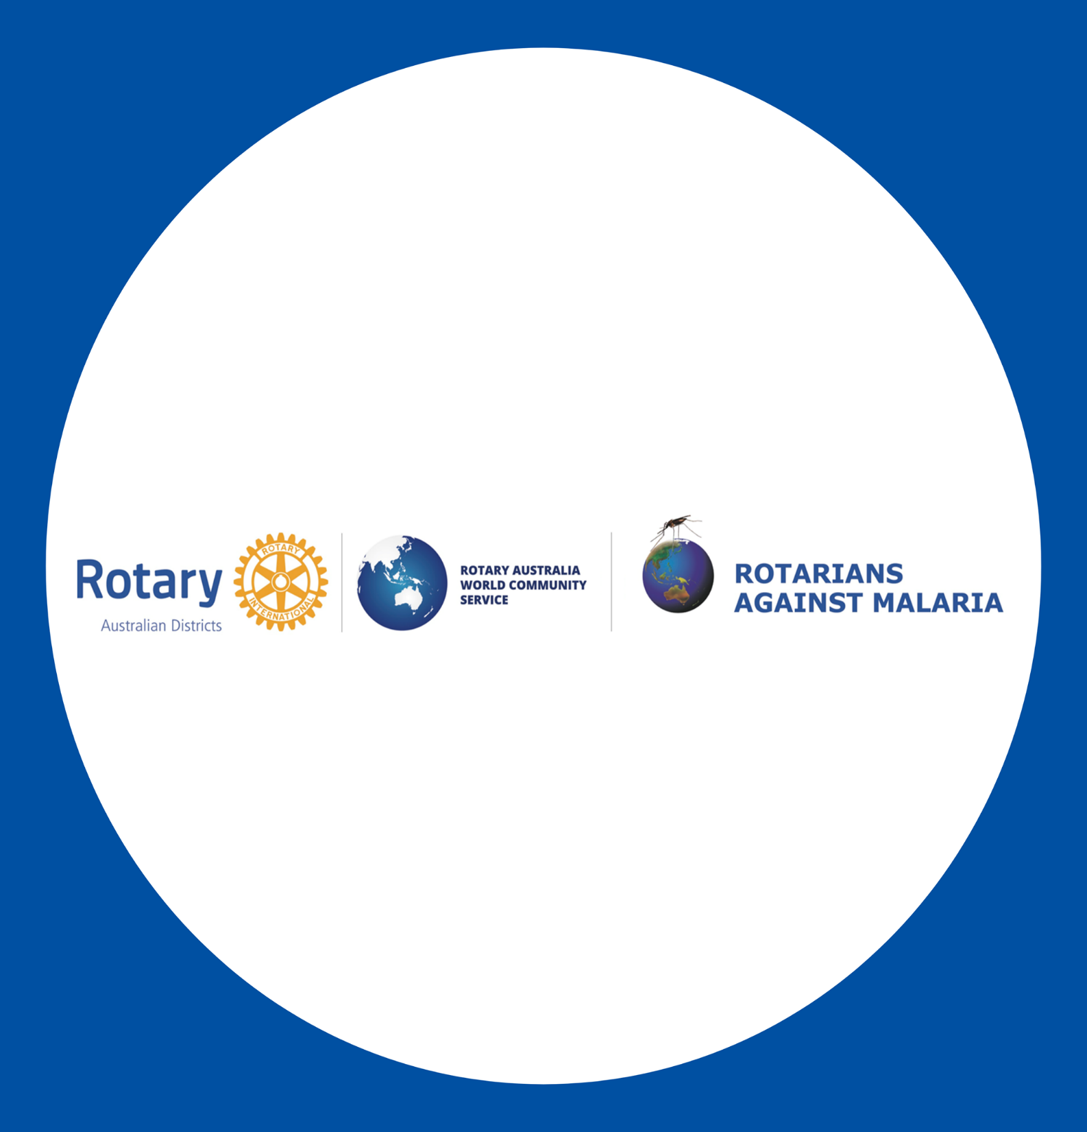
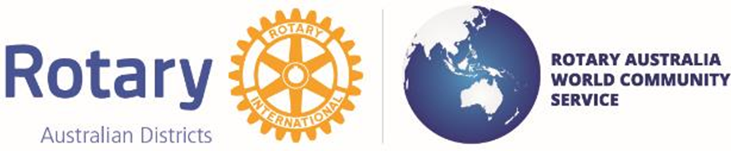
Rotary Australia World Community Service -RAWCS
Rotarians Against Malaria – RAM Western Region D9423
RAWCS registers all Rotary projects including RAM Malaria projects and this gives Tax deductibility for your donations.
RAM Western Region currently operates in West Timor and in East Sumba Island NTT Province Indonesia focusing on Malaria Elimination for WHO Malaria Free Certification and Water and Sanitation projects.
Rotary Club Hillarys, RAM Aust. and RAM Global, D9423 Partnered with RAWCS and Districts in Tas. Vic and ACT and the Rotary Club West Perth receiving 2 Global Grants for Zero Malaria in West Timor with 2 Rotary Clubs in Kupang, West Timor D3420.
Rotary Club Mandurah has PDG John Kevan Project Manager RAWCS Project #10-2023-24 has partnered with RAM Aust., Lab Without Walls and Fair Future Foundation now raising funds of AUD$125,000 for Malaria Elimination and Water Connections in 6 villages on East Sumba Island, NTT Indonesia.
RAM is proposing a Volunteers tour to East Sumba Island in March 2025 to include Pasola festival, in Tambolaka – Sodan Tambolaka, the Ancient Ritual at the start of the planting season.
West Timor – Rotarians Against Malaria Australia (rawcs.com.au)
