Saturday Afternoon Conference Tours - June 11th 2016
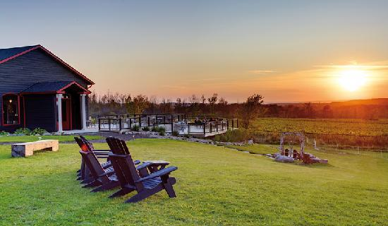
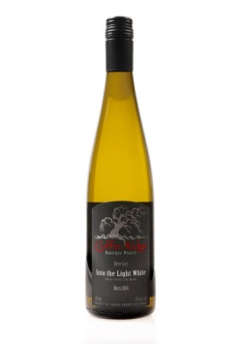
Participate in ONE of the following local Tours
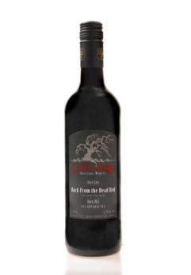
1) **Coffin Ridge Wine Tour - visit our local vineyard for tour & tastings - famous for ‘Into the Light White’ wine; ‘Back from the Dead Red’ wine; and ‘Resurrection Rose’ wine
or
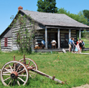
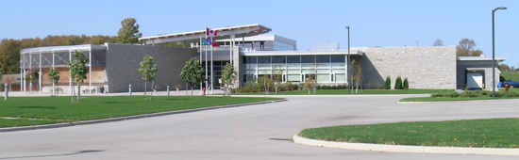
2) **Grey Roots Museum Archives and the Moreston Pioneer Village - featuring Owen Sound & Grey County history plus an actual Pioneer heritage village
or
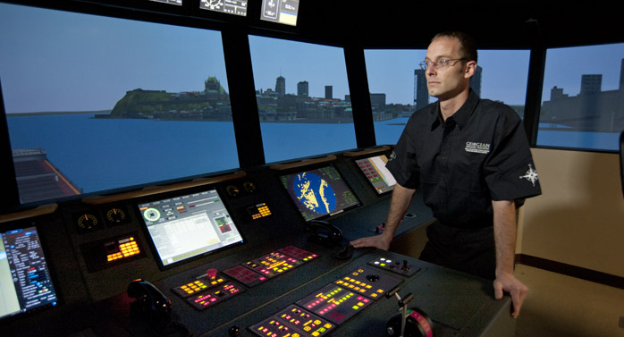
3) **Georgian College Marine Ship Training Simulator - participate on an actual Ship Training Simulator. Experience how the Georgian College Marine students train for ship handling. Feel the waves!

**Bus transportation will be provided for 1, 2, & 3
or

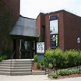
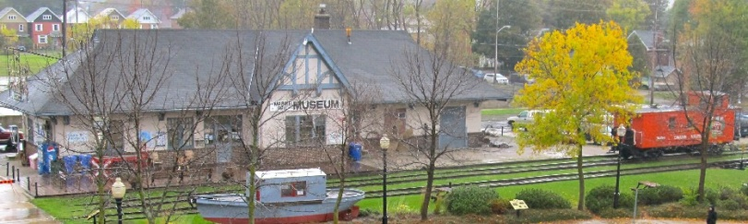
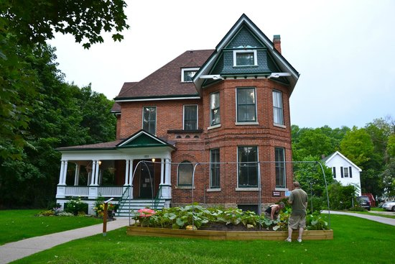
4) Owen Sound Downtown Walking Tour - including Tom Thompson Art Gallery, Billy Bishop Home & Museum, Owen Sound Marine & Rail museum situated along the Sydenham River with walking paths to enjoy. Enjoy our Downtown Area!

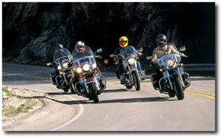
Motorcycle Tour for Polio - for the Motorcycle enthusiasts!
Enjoy one or both of the scenic Tours of our Area being offered.
Thursday Afternoon June 9th is the Northern Exposure Ride. Saturday Afternoon June 11th is the Beaver Valley River Rat Ride.

