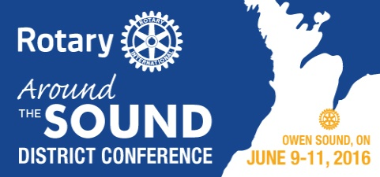**District 6330 Conference Program -- Owen Sound ON --**

**June 9 to 11 2016**

**REGISTRATION DEADLINE - JUNE 4TH 2016**

**Thursday June 9th** - ***Golf tournament*** at Legacy Ridge Golf Club - Shotgun start at 1:00 pm 18 holes of Golf and Dinner with Optional Lunch

***Motorcycle Tour for Polio***

**Friday June 10th** **PDG Meeting**

**House of Friendship Opens:**  “***Rotarians at Work to Be a Gift to the World”***

***Lunch*  - 11:45 am -Official Conference Opening** - Bayshore Community Centre

Speaker: ***RI Rep: PDG Jim Jeselnick***

***Afternoon Plenary* sessions**. **1:45 pm** No Breakout sessions. We encourage all Rotarians, Partners & Guests to join in and hear our local speakers: ***Allen Smutylo; Michael Dentandt****;* ***& David Sweetnam*** share items of interest for all.

**Celebration of Life 4:30pm** to honour Rotarians who have passed



***Dinner*** **6:20 pm** is the **World’s Greatest Meal for Polio** -

**Speaker *Susanne Rea*** - of the Rotary Club of Cairns Sunrise in Australia who was involved in the founding of this worldwide Polio fundraiser

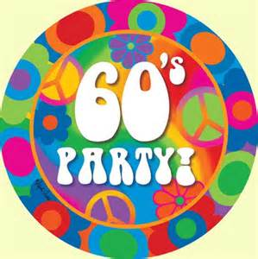

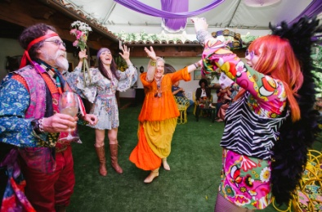**Evening Entertainment –“Back to the 60’s” theme**

*Wear your bell bottoms, peace beads, head bands!* And enjoy the music of the band  **‘1969 Revisited’**

**Saturday June 11th *Morning Plenary-* 8:40 am Session opens** featuring:

Speaker ***PDG Doug Vincent***, Motivational Speaker ***Shawn Casemore***; Award presentations; District Conference 2017 preview; and District Business Meeting

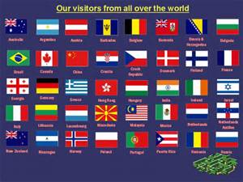

***Lunch* - 12:25 pm** features the **Parade of Flags** with the Rotary exchange Students and Interact Students

**Speaker: *Larisa Yurkiw* - Canadian Cup Alpine Ski Racer**

**Free Time**  (**2:30pm to 4:30pm**) in **Afternoon** for **local Tours** and sights of interest. **Pre-registration** is required.

 ***Evening Program*: Governor Reception - 5:30 pm**

***Dinner***  **6:30 pm**

Speaker: ***RI Rep: PDG Jim Jeselnick***

**Key note speaker - *Alan Mallory***

“***Taking Leadership to New Heights***”

Sharing the story of his family’s climb of Mount Everest