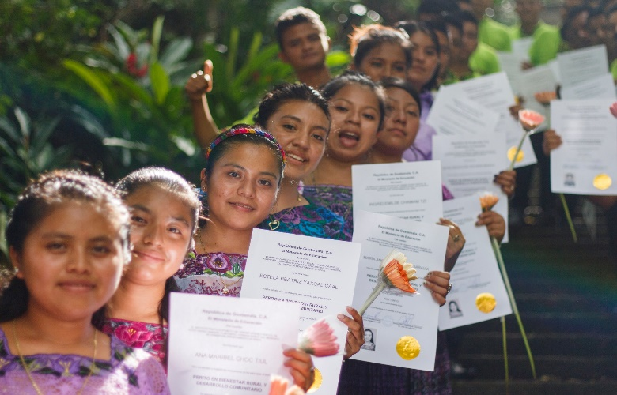

Ak’ Tenamit: A Mayan Term Meaning “New Village”
Ak’ Tenamit was started in 1990, with a first class of 11 boys and 3 girls. It was founded by Steve Dudenhoefer from Florida, who remains today as the Chief Technical Advisor of Asociación AK’ Tenamit. The school today has over 600 Indigenous Mayan students and is managed entirely by the Q’eqchi people. It is viewed as a model globally for its effective grassroots approach to vocational education, income generation, and health care. The goals of Ak’ Tenamit are to:
- Provide shelter and education for at-risk youth aged 12-18
- Help youths develop skills and gainful employment
- Establish internships and job opportunities
- Provide initial financial and emotional support for graduates to help ensure success
Hands-on experiences provide the knowledge and skills for gainful employment in Guatemala, which offers an alternative to migration. An outstanding number (85%) of students are employed shortly after graduation. This is because prior to graduation, students complete extensive work study programs in businesses off-campus. After employment, graduates pledge to give back a percentage of their income to their villages.
Rotarians have been huge supporters of Ak’ Tenamit for over 20 years, contributing medical supplies and equipment, funds, and labor to build new dorms and classrooms, a floating dental clinic, solar energy equipment, computer labs, restaurant equipment and supplies, new boat engines, and family water filters.
Each year, groups of Rotarians from all over the USA spend a week at Ak’ Tenamit to gain an understanding of the need of the children, and to provide assistance at the school. Districts 6930, 6990 and 5240 are now recruiting Rotarians and friends for a trip in February 18-25, 2024. Please see attached flyer.
“The best way to find yourself is to lose yourself in the service of others.” Mahatma Gandhi

