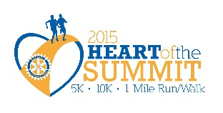
The 5th Annual
Heart of the Summit
5K/10K/1 mile Walk/Run
September 12, 2015
8:00 AM – 10:00 a.m.
Downtown Lee’s Summit (3rd and Green)
Sponsorship Registration
Heart of the Summit is a walk/run sponsored by the Rotary Club of Lee’s Summit.
A benefit for the First Responders LSPD and LSFD
Please return this form by August 15th, 2015

Company Name: ____________________________________________________
(as you would like it to appear on race materials)
Contact Name: ___________________________ Contact Phone: ____________
Email: _________________________Website:____________________________
Address: ___________________________________________________________
(street) (city, state) (zip)
I will have an item for registration bags Yes No

Please contact me regarding volunteer Opportunities Yes No

Please return this form and your check payable to Lee’s Summit Rotary Foundation – memo Heart of the Summit to Rotary Club of Lee’s Summit, P O Box 785, Lee’s Summit, Mo. 64063 Attn: Rob Sauve Questions call Susan Coffman at 816-835-3459 or email Coffman.susan@gmail.com

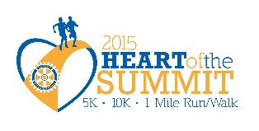Level - $1500
- Signage on day of race
- Company logo prominently displayed on Web Site*
- Company logo on race t-shirt (black & white)
- Company logo on race fliers*
- Company recognition in race day packets
- Name recognition in local pre-race advertising
- Name recognition in local post-race advertising
- Thank you acknowledgement announcement on race day
- Table for Promotional Purposes
- Ten complimentary race entries for walk or run
Level - $1000
- Company logo prominently displayed on Web Site*
- Company logo on race t-shirt (black & white)
- Company logo on race fliers*
- Company recognition in race day packets
- Name recognition in local pre-race advertising
- Name recognition in local post-race advertising
- Thank you acknowledgement announcement on race day
- Table for Promotional Purposes
- Eight complimentary race entries for walk or run
Level - $500
- Company name prominently displayed on Web Site*
- Company name on race t-shirt (black & white)
- Company name on race fliers*
- Company recognition in race day packets
- Name recognition in local pre-race advertising
- Name recognition in local post-race advertising
- Thank you acknowledgement announcement on race day
- ½ Table for Promotional Purposes
- Six complimentary race entries for walk or run
Level - $250
- Company name prominently displayed on Web Site*
- Company name on race t-shirt (black & white)
- Company name on race fliers*
- Company recognition in race day packets
- Name recognition in local pre-race advertising
- Name recognition in local post-race advertising
- Thank you acknowledgement announcement on race day
- Four complimentary race entries for walk or run

