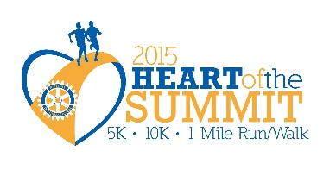
Lee’s Summit Rotary Foundation
EIN # 43-1873457

Dear Friend,
Steering Committee:

Brad McCleary
Bodies Personal Training
(Co-Chair)

Jeff Silver,
Allstate Insurance
(Co-Chair)

Chrissy Graheck
Paychex

Mike Allen,
John Hancock Financial Network

Leigh Ann Nelson,
Spilker McKeone & Nelson, PC

Rob Sauvé,
Rotary Club Lee’s Summit, Treasurer

Kirby Asplund
The Asplund Group LLC
Susan Coffman
Lee’s Summit CARES

Lee’s Summit Rotary Club is making plans for the fifth annual Heart of the Summit on September 12, 2015 at 8:00 am -10:00 am. At the 2013 event we had approximately 500 participants and volunteers. The success of this event is credited largely to sponsors like you who lend their names and financial support. Because of the generosity of our sponsors, 100% of the net proceeds is used to support local projects for the Lee’s Summit Police Department and the Lee’s Summit Fire Department. This year’s goal is to have 1,000 participants and volunteers and to raise $30,000.00.

Family Fun is on the agenda. We will have face painters, Sports personalities and vendors with activities for the youth. We also plan to have a food vendor for snacks.

As a sponsor, your organization will benefit from extended exposure through media campaigns and promotional efforts directed toward the supporters of Rotary International and First Responders. For a small donation, you will receive excellent exposure to an important segment of your target audience.

We have four levels of sponsorship packages as detailed in the enclosed sponsorship commitment form. You can select the level of participation that best meets your needs and be secure in the knowledge that your sponsorship fee will be used to assist with needs of the Lee’s Summit Police Department and the Lee’s Summit Fire Department.

If you have any questions contact Susan at 816.835.3459 or Coffman.susan@gmail.com. Please return your sponsorship commitment form no later than August 15th in order for your organization to be included in all the promotional materials offered to your level of sponsorship.

The Lee’s Summit Rotary Club is proud to once again present this great community event and we hope that you will join us as a sponsor at a level appropriate for your organization. Also, please consider forming a corporate team so that your business can compete in the biggest or fastest team contest. It’s a great corporate team builder!

Thank you in advance for your willingness to support the efforts of Rotary and the First Responders who serve our community.

We're counting on your support!

Susan Coffman Brad McCleary
Event Chair

