Winnetka-Northfield Rotary Club presents:
A Night at the Cabaret
Friday, May 13th , 2016
5:30-10:00pm
Michigan Shores Club, Wilmette
Featuring a performance by AOK Cabaret,
Silent Auction
Buffet Dinner, Cash Bar
Valet parking included
Tickets $90 single, $175 couple
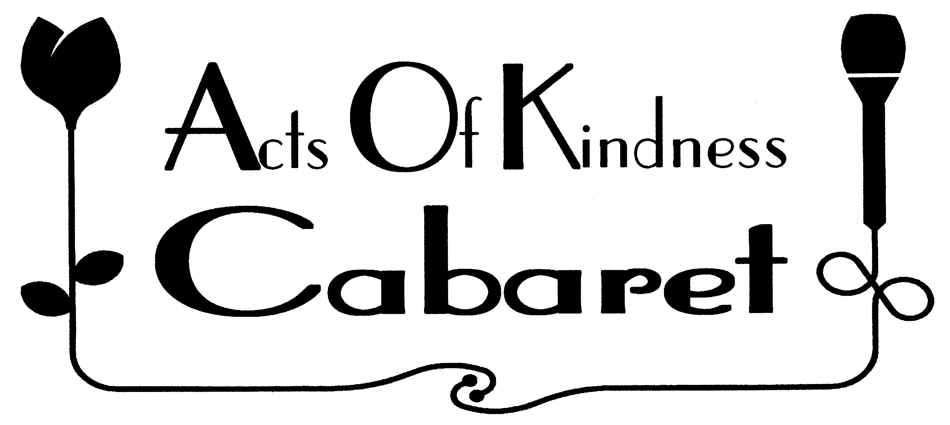
Funds raised support our foundation’s Community Grants program. Make checks payable to WNRCF.

