13th Annual Sporting Clay Shoot at Kiowa Creek
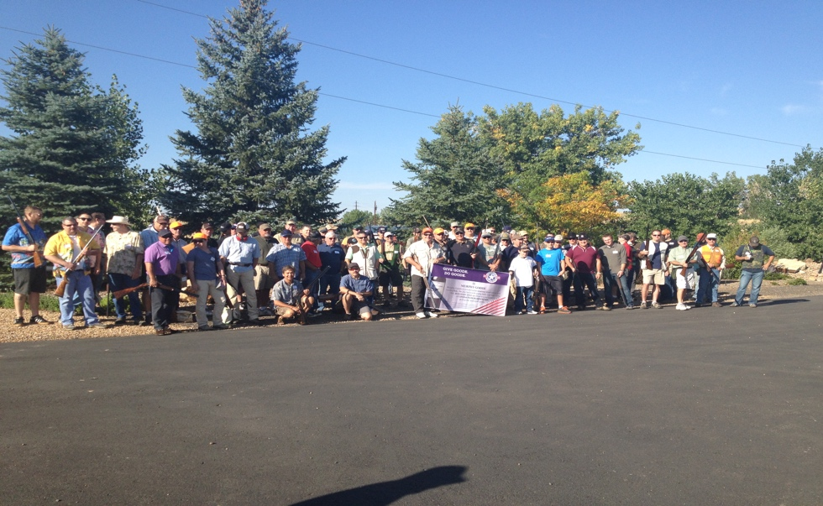
SATURDAY, AUGUST 20, 2016
REGISTRATION: 7:45 AM
SHOTGUN START: 8:45 AM
INDIVIDUAL SHOOTER: $150.00 SQUAD OF FOUR: $560.00
SQUAD OF FIVE: $700.00
KIOWA CREEK SPORTING CLUB BENNETT, CO
LIGHT BREAKFAST & LUNCH PROVIDED WITH REGISTRATION
PRIZES AWARDED & SILENT AUCTION AT LUNCH
FOR REGISTRATION OR MORE INFORMATION:
EMAIL: Paul DeCoste terpfan431@gmail.com or 720-556-5297
Proceeds go to DSE Foundation in support of Denver area community- based initiatives for Veterans & Education & Literacy for CIHad
(Colorado I Have a Dream Foundation).
SPONSORSHIP OPPORTUNITES AVAILABLE ALSO!

