Rotary Clubs of Mississauga
TICKET ORDER FORM
Toronto Maple Leaf Alumni Charity Hockey Event
Column Numbers
1 | 2 | 3 | 4 | 5 | 6
 |  | Price |  | Sub-total $ |  | Grand
Ticket Qty | Section | Adult | Child | Adult | Child | Total $
 |  |  |  | =1x3 | =1x4 | = 5+6
 | 1 | $25.15 | $8.20
 | 6 to 8 | $27.70 | $10.75
 | 13 to 14 | $25.15 | $8.20
 | 19 to 21 | $34.10 | $17.15
 | 26 | $25.15 | $8.20
 | OTHER Sections | $25.15 | $8.20
 |  |  | Total Tickets
 |  |  | Less P.Ticket | $3.40 | $1.13
 |  |  | Net
 |  |  |  |  | TOTAL
All Prices Are CASH ONLY and include Hershey Centre Capital Replacement Surcharge of $2.25 & HST
Add-on $5 flat rate per person (regardless of age) to meet the players plus an on-ice skate pre-game 150 maximum participants
NOTE: Additional fees will apply when purchasing online via Credit Card and through Ticketmaster.
Name …………………………………………………………………
Address …………………………………………………………………
City …………………………………………………………………
Date …………………………………………………………………
Comments or Suggestions:
The Rotary Clubs of Mississauga Thank You for attending this exciting event and supporting local charities.
We do not deduct any amount for Administration fees at any time in any of our efforts to make our community a better place.
ARENA LAYOUT
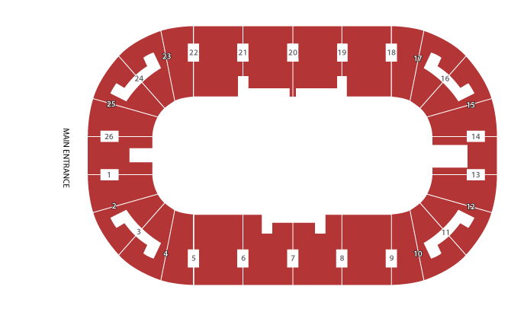
The event will be assigned seating with ticket prices as follows:
ADULT (ages 13+) | BEHIND PLAYER BENCHES  19-21 | BEHIND PENALTY BOX  6-8 | BEHIND NETS  26-1 & 13-14
BASE PRICE | $ 27.90 | $ 22.25 | $ 20.00
CRS | $ 2.25 | $ 2.25 | $ 2.25
SUB-TOTAL | $ 30.15 | $ 24.50 | $ 22.25
HST | $ 3.92 | $ 3.19 | $ 2.89
TOTAL | $ 34.07 | $ 27.69 | $ 25.14
ROUNDED | $ 34.10 | $ 27.70 | $ 25.15
CHILD (ages 3 - 12) | BEHIND PLAYER BENCHES  19-21 | BEHIND PENALTY BOX  6-8 | BEHIND NETS  26-1 & 13-14
BASE PRICE | $ 12.90 | $ 7.25 | $ 5.00
CRS | $ 2.25 | $ 2.25 | $ 2.25
SUB-TOTAL | $ 15.15 | $ 9.50 | $ 7.25
HST | $ 1.97 | $ 1.24 | $ 0.94
TOTAL | $ 17.12 | $ 10.74 | $ 8.19
ROUNDED | $ 17.15 | $ 10.75 | $ 8.20

 | DETAILED TICKET PURCHASES
 |  |  |  |  | Tickets
 |  |  |  |  | Adult |  |  | Child |  |  | Grand
 | Purchaser |  |  | Section | # Req'd | Cost | Total $ | # Req'd | Cost | Total $ | Total $
 | Name
 | Address
 | Name
 | Address
 | Name
 | Address
 | Name
 | Address
 | Name
 | Address
 | Name
 | Address
 | Name
 | Address
 | Name
 | Address
 | Name
 | Address
 | Name
 | Address
 | Name
 | Address
 | Name
 | Address

