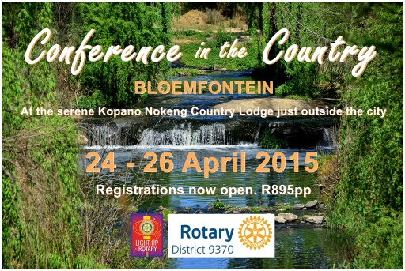

Registrations for the district conference are now open. The conference committee promise a really interesting and inspiring conference. We have some really world class speakers including, amongst others, Douglas Kruger, Sheri Brynard, Louise van Rhyn (Partners for Possibility) and Pat Hackett. Below is a registration form which will also be available on the district website soon.

ACCOMMODATION INFORMATION (Nearby Kopano Nokeng)

Maselspoort - 051 441 7848
Road Lodge - 051 411 0200
Groen Akker - 051 411 7765
Tuff Top - 051 411 7610
Swan Lake - 082 226 5071
Palmalot - 082 440 6013
Vallombraso - 082 556 1909
Indaba lodge - 082 226 5071

Come and experience real Free State hospitality, fresh air and be enriched!

DISTRICT CONFERENCE 2015
24 to 26 April 2015
REGISTRATION FORM
____

Please complete this form in BLOCK CAPITALS and return to
Hilary Augustus email –aug@iafrica.com
P O Box 20209 or fax a copy to 086 694 6677
Durban North 4016 Tel: 031 564 2114 / 082 556 0299

Surname Call name Initials
Ann / Partner’s Surname Call name Initials
Rotary Club of Delegate’s ID No
For reference purposes
Please tick appropriate boxes:
PDG President Past President Paul Harris Fellow Rtn
Rotarian President Elect Ann/Partner (please indicate) Paul Harris Fellow Ann/Partner
PDG Ann Rotaractor Youth Exchange First Conference Rtn
Interactor Ambassadorial G S E First Conference Ann/Partner
Other - Specify
Tel (incl. code) (B) (H) Fax
Cell: e-mail:
Please tick relevant boxes and add total:
Function | Rtn | Ann | Partner/Other | Amount | Total | Dietary requirements (please specify
Friday Registration/Meet & Greet (including snacks) |  |  |  | R 70.00
Conference Participation 25,26 Apr (incl. Lunches/Teabreaks)  OR |  |  |  | R 525.00
Conference Participation 25,26 Apr
(incl. Anns Morning 26 Apr)
Saturday Dinner |  |  |  | R 120.00
Sunday Banquet |  |  |  | R 180.00
 |  |  |  | TOTAL

I hereby confirm my registration as above and accept liability for payment of R
Signed________________________________

Transfers can be made to : Discon 9370, Std Bank Ladybrand; Branch Code: 055633; Acc 244576076
Please include your full name and Identity number as a reference and email proof to aug@iafrica.com

PLEASE NOTE: COST FOR REGISTRATION LATER THAN 01 APRIL 2015: R 945.00
For office use:
Registration No. | Date: | Receipt No.

