Speed Dating “Rotary Style”
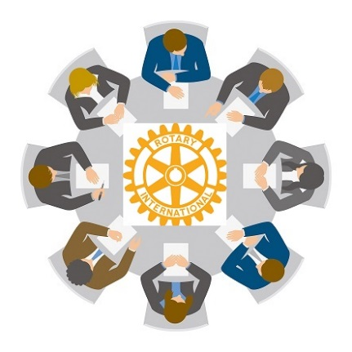
Think “hooking up” with ideas, not people.
Join us on September 26th for a new way to learn about Rotary.
Break Out Session Topics:
- Membership w/focus on building members via Interact and Rotaract
- Public Relations w/focus on Club Runner and Websites
- The Rotary Foundation w/focus on how fund raising supports programs
- Rotary “101” … a guide to all things Rotary
(especially for newer members though a great refresher for seasoned members, too!)
Area Governors will meet for a special briefing withDG Jim Nelson and DGN Mark Hegstrom
And, Presidents Elect will also have their own special meeting with your DGE, Tim Murphy.
And we’ll hear from our own Tom Thorfinnson, PRID, at lunch!
It’s time to register!
Make it officia1. Register BEFORE September 15th!
Details
September 26, 2014
8:00 am – 1:30 pm
Earle Brown Heritage Center
6155 Earle Brown Drive, Brooklyn Center, MN 555430

