Panther Prowl and 5K Run for Education
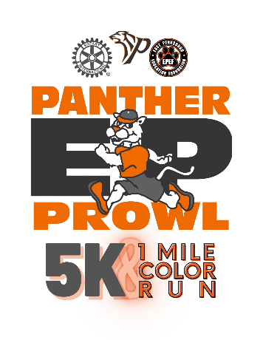
All proceeds to be used for education including scholarships for deserving seniors at East Pennsboro High School, Cumberland Valley High School, and Cumberland-Perry CPT High School as well as the East Pennsboro Educational Foundation and East Pennsboro High School Track Team.

Where: Sunday April 30, 2023- Registration at 11am, 5K Run at Noon and One Mile Color Run at 1pm

Where: East Pennsboro High School Track

Pre-Registration
https://runsignup.com/Race/PA/Enola/PantherProwl5KRunforEducationandOneMileColorFunRun

Gold Sponsor ($1,0000)
- Online Exposure on Registration website,
- Eight Complimentary Registrations
- Company logo printed on banner to be displayed at registration
- Company logo printed on directional signs located on course
- Company name printed on shirt
- Company name mentioned during event presentation.
- Item in participants’ gift bag opportunity

Silver Sponsor ($500)
- Online Exposure on Registration website
- Four Complimentary Registrations
- Company name printed on shirt
- Company name mentioned during event presentation.
- Item in participants’ gift bag opportunity

Bronze Sponsor ($100)
- Online Exposure on Registration website
- Two Complimentary Registrations
- Company name mentioned during event presentation.
- Item in participants’ gift bag opportunity

Name Phone Number

Company E-mail Address

Please send logo to Ken Hugendubler no later than April 1 and payment is due by April 15. Please contact him at 717.319.5440 or ken.hugendubler@bakertilly.com

