The Kuyahoora Valley Rotary Club
Invites you to attend the
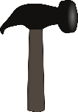OOLBO BASH
Live Music, Dinner and Dancing
Live Music by
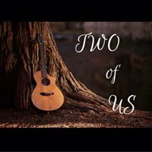
Saturday, October 20, 2018 6:30 pm at the
Miners’ Table Restaurant
4579 STATE ROUTE 28, HERKIMER, NY

Cocktail Hour Music by
“Tony & Tacie”

A benefit to support a joint project in the Kuyahoora Valley with:

Tickets on sale at: www.kuyahooravalleyrotary.org, our Facebook page, or email us at kvrc.toolboxbash@gmail.com
$40 each or $75 per couple

Major Sponsors:

“We have been part of this Community since 1913. Technology has changed significantly but our core values and commitment to our customers has not.”

www.ntcnet.com
