Go Red Sox!
Why fly to Florida when you can watch the game
in Bolton for free?

Get your root beer here… Fenway Franks, peanuts, and Cracker Jack, too! Feel like you are at the ball park. Watch the baseball game on our big flat-screen TV.

Boston Red Sox vs. Tampa Bay Rays
Home Opening Day: Thursday, April 5, 2018 at 1:30 PM
Game starts at 2:05 PM
Bolton Manor Community Room:
600 Main Street, Bolton

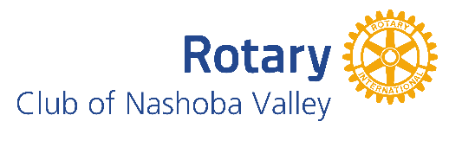
Please RSVP: Sign-up sheet or 978-627-4135

Sponsored by the Rotary Club of Nashoba Valley
& Bolton Council On Aging

