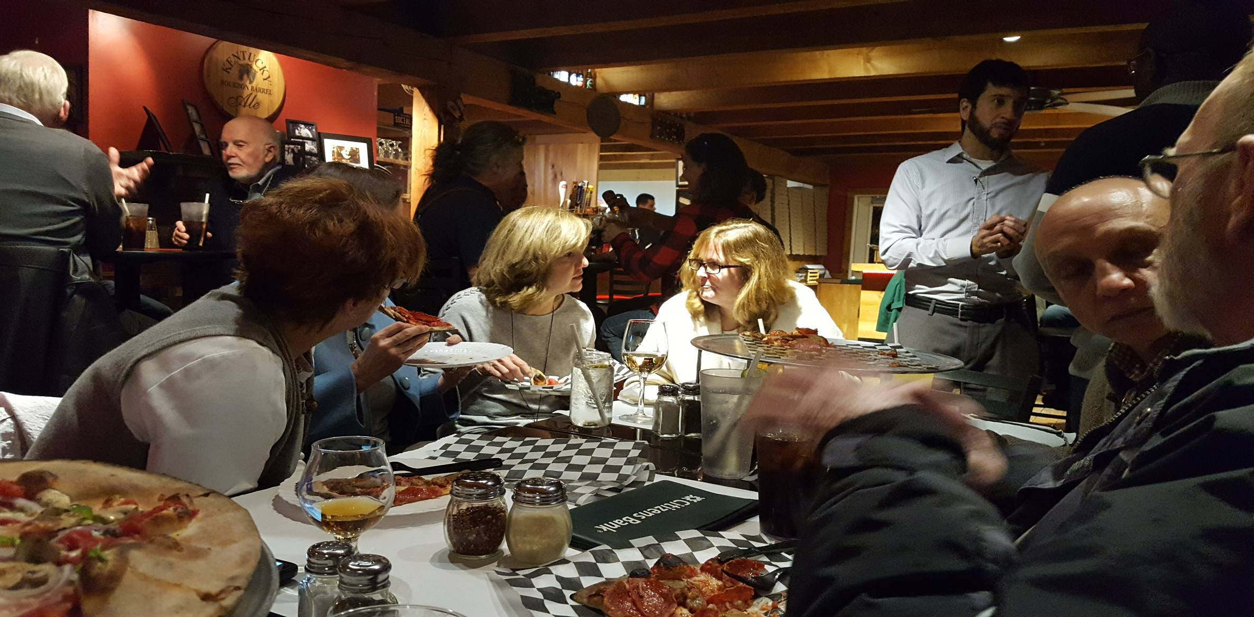

MONTHLY SOCIAL GATHERING

Tuesday, July 23, 2019
6:00 – 8:00 PM
Slater’s
356 Main Street (Route 117), Bolton, MA
$10 for pizza,
cash bar available
All are invited
info@nashobarotary.org
or 978-627-4135
Walk-ins welcome!

JOIN US FOR SOCIALIZATION AND SERVICE

Every month the Rotary Club of Nashoba Valley meets in the spirit of friendship AND community service. Friends, neighbors, and interested prospective members are always welcome to join us. We love meeting new people, and Slater’s has awesome wood-fired pizza, BBQ, and libations as well as a fun, friendly atmosphere.

Learn more, including each month’s
service project:

www.nashobarotary.org facebook.com/nashobarotary

Donations requested for Household Goods:

- Kitchen items: pots and pans, bakeware, cooking utensils, dishes, glasses, flatware
Cannot accept stemware, mugs and glasses with logos
- Linens: mattress pads, sheets, blankets, comforters, new pillows, towels, curtains, curtain rods
Cannot accept electric blankets, mattress toppers, blinds, shades, custom window treatments

JOIN LEADERS

