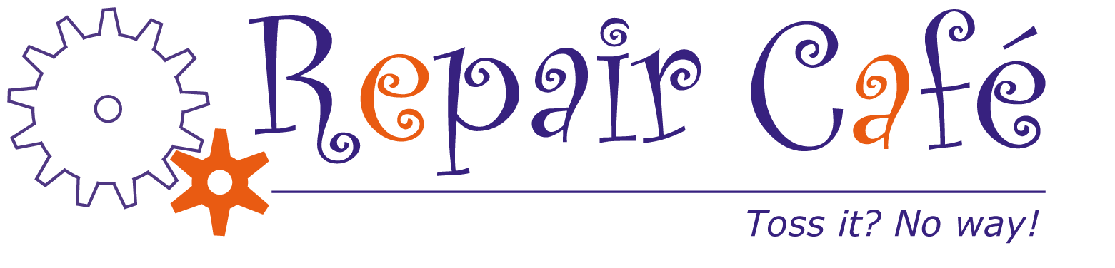

THE FIX IS FREE AT THE REPAIR CAFÉ

Most items are welcome for free repair. We specialize in mendable clothing, lamps, small appliances, computers, electronics, sewing machines, bikes, toys, outdoor equipment, and sharpening dull knives or garden tools. If your item needs a part, save time and bring the new part with you.

Sat., Oct 28, 2017
9 a.m. - 12 noon
Sudbury Senior Center
40 Fairbank Road
Sudbury, MA

Enjoy a free drink and a snack, have fun, and work with a volunteer to repair your broken item.

For information or to volunteer:
Contact Howard Kendall at
978-261-5264 or howard.kendall@comcast.net
Learn more at www.repaircafe.org

You know all about the small print, right? But our small print says the same thing as our big print: There is no charge...really! You just pay for any needed parts.

An all-volunteer project of the Rotary Club of Nashoba Valley with support from the
Sudbury Senior Center and the Sudbury Historical Society.

y HSociety

