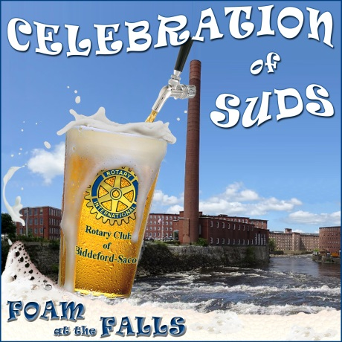

Sponsorship Opportunities

Saturday, October 20, 2018 7 – 10 pm
Pepperell Mill Campus, 40 Main St, Biddeford

Keg: $500
Proceeds benefit our charitable fund

- Named in press releases
- Listing on event and Rotary website
- Acknowledgement on Rotary Facebook Page
- Thank you sign at event
- 4 complimentary tickets

Growler: $250
- Named in press releases
- Listing on event and Rotary website
- Acknowledgement on Rotary Facebook Page
- Thank you sign at event

Pint: $150
- Listing on event and Rotary website
- Acknowledgement on Rotary Facebook Page
- Thank you sign at event

Any other amount is appreciated.

Company Name (as you wish it to be publicized): ______________________________________________
Contact Person: _________________________________________________________________________
Address: _______________________________________________________________________________
Town/State/Zip Code: ____________________________________________________________________
Phone: __________________________ Email: _______________________________________________

Please make checks payable to Rotary Club of Biddeford Saco and mail to:
Celebration of Suds
Rotary Club of Biddeford Saco
PO Box 298
Saco, ME 04072

