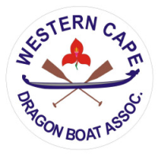
The Rotary Club Cape of Good Hope

DRAGON BOAT REGATTA

Imperial Yacht Club
Promenade Road – Zandvlei
Lakeside

Saturday 06 April 2019 @ 09H00 – 15H00
Registration Form
Name of :
Company or Organisation
Name of Team
Contact Person
Contact  Details | Phone :
 | Cell :
 | E-mail :
Cost for an 11-Man Team is R 5 000

Each Team to have a REGISTERED NAME and to consist of 10 x Paddlers and 1 x Drummer
Teams are encouraged to dress in a Uniform / Fancy Dress which adds to the “Vibe” on the day
Electronic Banking Details : |  |  | Registration Assistance :
Bank : | NEDBANK – Noordhoek Branch |  | Susan O’ Hagan Ward
Bank Code : | 125 009 |  | Phone : 021 785 6798
Account Name : | The Rotary Club Cape of Good Hope |  | Cell : 082 964 9698
Account No. : | 1169 110207
Reference : | Your Name and “Dragon Boat” |  | Invoice Available on Request
Please pay in advance to secure your slot
Kindly e-mail Completed Registration Form and Proof of Payment to : susan@jap.co.za
Thank You for your Valued Support

