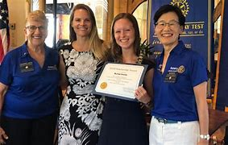  - Kuleana – A course  in leadership  Rotary District 5000 presents a set of classes…  …starting with “kuleana” (responsibility) this set of four sessions combines basic Rotary leadership concepts with Hawaiian cultural aspects to bring a unique type of leadership training that will serve participants not just in Rotary but in their business and professional careers. These classes are designed for emerging Rotary leaders or any person in D5000 who has an interest in developing their leadership capabilities. Presentations by leadership experts, current CEO’s and community leaders will give participants a firsthand look at what it takes to lead others, especially volunteers. Join Immediate Past District Governor Naomi Masuno and District Trainer Benson Medina through a series of four classes (attend all or just the ones that spark your interest) that will give you a new perspective on leadership and help you define your own unique leadership style. | Four Sessions  ____  Saturday, Sept. 4 Kuleana - Responsibility  ____  Saturday, Nov. 6 Lawelawe - Service Leadership  ____  Saturday, Feb 5  Lokahi - Unity  ____  Saturday, April 30 Olelo - Communication  All Sessions Online  Attend All Sessions and Receive a Certificate of Completion  https://zoom.us/j/94810456899  Saturdays 9 am – 11 am

