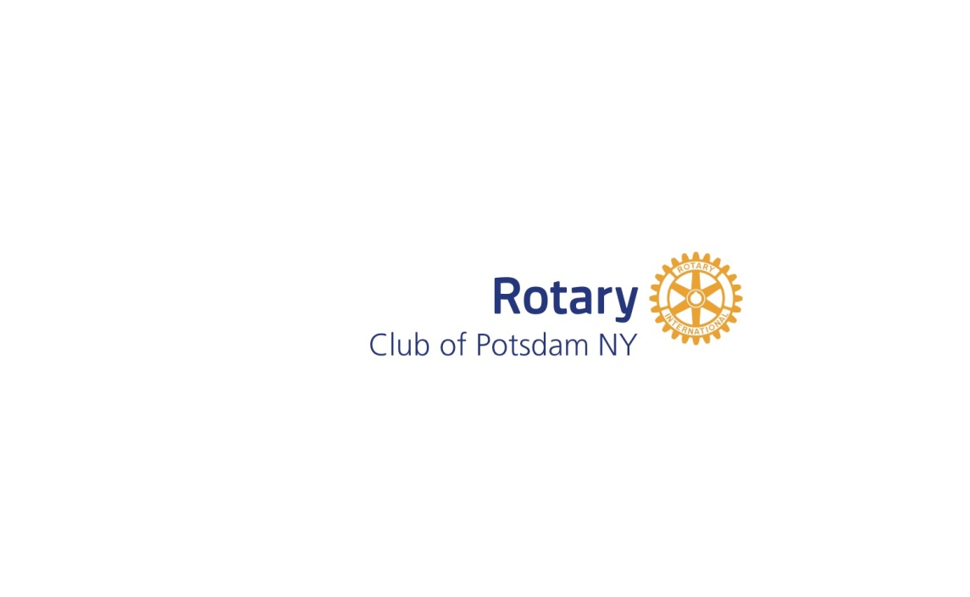

Friday, May 15, 2021
Come golf with Rotary!

$90 / person…Golf, Lunch & Seafood / Clam Bake
$360 / foursome

Come support
Potsdam Rotary’s BOCES Scholarship Program
and
Potsdam High School Scholarship
Dodge Pond scholarships for children with disabilities
Rotary Youth Leadership Award
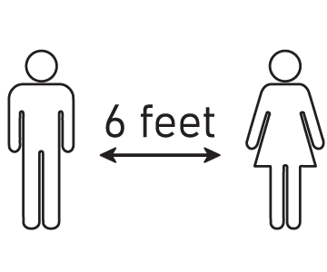
Please remember your mask and
Practice social distancing

To register and become a sponsor, please reply by April 30th at potsdamrotary.org

1st Place: Cash Prize
2nd Place: Cash Prize
Putting Contest
Beat the Pro
Lottery Ticket Chance

More info: potsdamrotarygolf@gmail.com, 315.742.2555

