Post Office Box 912
Potsdam, NY 13676

Registration/Sponsorship Form

**Sponsorship Information is on the back of this form**

Welcome to Rotary’s 17th golf tournament! To register and sponsor, please reply by April 30th:
- Online, using your credit card via our event link on potsdamrotary.org
- Email: download this form at potsdamrotary.org and email it to potsdamrotarygolf@gmail.com
- Mail: make checks payable to Potsdam Rotary Club, PO Box 912, Potsdam, NY 13676-0912

We can accommodate the first 35 Teams to register. Let us hear from you soon!

Prices are as follows:
$90 per person (Golf, Lunch & Dinner)
$360 per foursome
Staying for
Member of PT&CC Dinner

1st Player___________________________ Y N Y N
2nd Player____________________________ Y N Y N
3rd Player____________________________ Y N Y N
4th Player____________________________ Y N Y N

Team Captain________________________ Email Address______________________________

Contact Phone Number_______________________

THANK YOU FOR YOUR SUPPORT!
If you have any questions, please contact any of the following committee members:
Christa Carroll, potsdamrotarygolf@gmail.com, 315.742.2555
Michael Griffin
Tanya Krise, tanyak@northerninsuring.com, 315.244.6652
Carol Hunter
Taylor Robertson

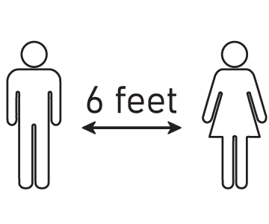
**Masks and social distancing will be required**

Potsdam Rotary
Annual Scholarship Golf Tournament—May 15, 2021
Sponsorship Levels

Sponsor Name:_________________________________

$800 _____ Hole-In-One Sponsor
- Team golf & dinner fees
- Promotional advertising

$550 _____ Eagle Sponsor
- 2 dinner tickets and Promotional advertising

$300 _____ Birdie Sponsor
- Promotional advertising

$150 _____ Par Sponsor
- Day of Event advertising

$______________ Other Cash Amount * Day of Event advertising

____________ Other Prizes * Day of Event advertising

____________ Gift Certificates * Day of Event advertising

Prizes –
1st Place: Cash Prize

After a fun day in the tournament,
join us for SEAFOOD / BBQ and AWARDS!
2nd Place: Cash Prize
Putting Contest
Beat the Pro
Lottery Ticket Chances

