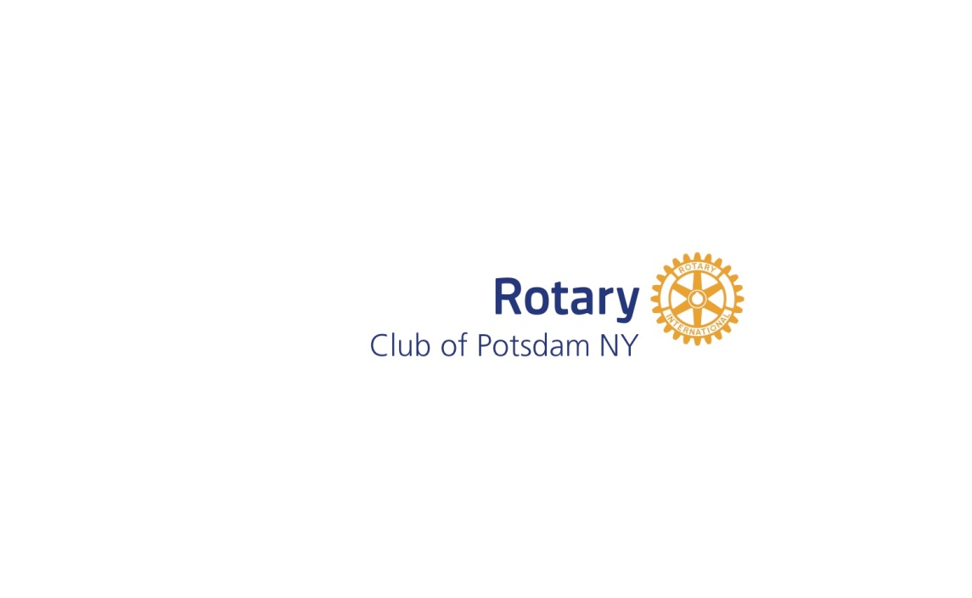

Post Office Box 912 Potsdam, NY 13676

Registration/Sponsorship Form

We welcome your foursome! To register and become a sponsor, please reply by April 27th:
- Online, using your credit card via our event link on potsdamrotary.org
- Email: download this form at potsdamrotary.org and email it to rotarygolf@twcny.rr.com
- Mail: make checks payable to Potsdam Rotary Club, PO Box 912, Potsdam, NY 13676-0912

This event will take place on Fri., May 11, regardless of weather, so no rain date or refunds will be offered, and we can include only the first 35 Teams to register. Let us hear from you soon!

Prices are as follows:
$85/per person (Golf, Lunch & Dinner)
$65/per person (Golf & Lunch)
$20-Dinner Only
Member of Potsdam Town & Country Club Dinner

1st Player___________________________ Y N Y N

2nd Player____________________________ Y N Y N

3rd Player____________________________ Y N Y N

4th Player____________________________ Y N Y N

Team Captain________________________ Email Address______________________________

Contact Phone Number_______________________

THANK YOU FOR YOUR SUPPORT!

If you have any questions, please contact any of the following committee members:
Christa Carroll, rotarygolf@twcny.rr.com, 315.212.1988
Vikie Jones, 315.268.1440
Duane Pelkey, duane.pelkey@communitybankna.com
Chamil Perera
Samantha Polnak
Steve Thornton

**Sponsorship Information is on the back of this form**

Potsdam Rotary
Annual Scholarship Golf Tournament—May 11, 2018
Sponsorship Levels

Sponsor Name:_________________________________

$750 _____ Hole-In-One Sponsor
- Team golf & dinner fees
- Promotional advertising

$500 _____ Eagle Sponsor
- 2 clam bake tickets and Promotional advertising

$250 _____ Birdie Sponsor
- Promotional advertising

$100 _____ Par Sponsor
- Day of Event advertising

$______________ Other Cash Amount * Day of Event advertising

________________Other Prizes * Day of Event advertising

________________Gift Certificates * Day of Event advertising
After tournament, drive over for CLAM BAKE and PRIZE AWARDS……
Prizes –
1st Place: Cash Prize
2nd Place: Cash Prize

Putting Contest 50/50 Raffle

