PO Box 912
Potsdam, NY 13676

Registration/Sponsorship Form

**Sponsorship Information is on the back of this form**

Welcome to Rotary’s 18th annual golf tournament to be held May 14, 2022! To register and/or sponsor, please reply by April 30th:

- Online, using your credit card via our event link on potsdamrotary.org
- Email: download this form at potsdamrotary.org and email it to golf@potsdamrotary.org
- Mail: make checks payable to Potsdam Rotary Club, PO Box 912, Potsdam, NY 13676-0912

We can accommodate the first 35 Teams to register. This will be “Captain & Crew” format. Let us hear from you soon!

Prices are as follows (Includes Golf, Cart, Prizes, Lunch & Dinner) :

$80 per person
$320 per foursome

Member of PT&CC

1st Player___________________________ Y N
2nd Player____________________________ Y N
3rd Player____________________________ Y N
4th Player____________________________ Y N

Team Captain________________________ Email Address______________________________

Contact Phone Number_______________________

THANK YOU FOR YOUR SUPPORT!

If you have any questions, please contact any of the following committee members:

Tanya LaShombe, tanyak@northerninsuring.com, 315.244.6652
Michael Griffin, mpgriffin@gmail.com, 315.265.5584
Taylor Robertson, 518.534.2863

Potsdam Rotary
Annual Scholarship Golf Tournament—May 14, 2022
Sponsorship Levels

Sponsor Name:_________________________________

$1,000_____ Hole-In-One Sponsor
- Team golf & hors d'oeuvres reception
- Promotional advertising

$500 _____ Eagle Sponsor
- 2 hors d'oeuvres reception and promotional advertising

$300 _____ Birdie Sponsor
- Promotional advertising

$150 _____ Par Sponsor
- Day of Event advertising

$______________ Other Cash Amount * Day of Event advertising

____________ Other Prizes * Day of Event advertising

____________ Gift Certificates * Day of Event advertising

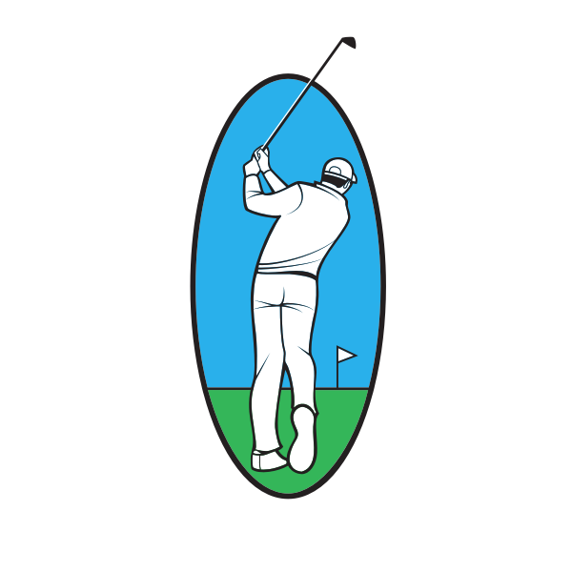
Cash Prizes For:

Men’s Flight, Women’s Flight, Mixed Flight,

Captain
&
Crew
Format

On the course contests:

Longest Drive (men/women), Beat the Pro
Closest to the Pin (men/women), Closest to the Center Line
Putting, Mulligans, and Skins

After a fun day in the tournament,
join us for food, drinks, and AWARDS!

