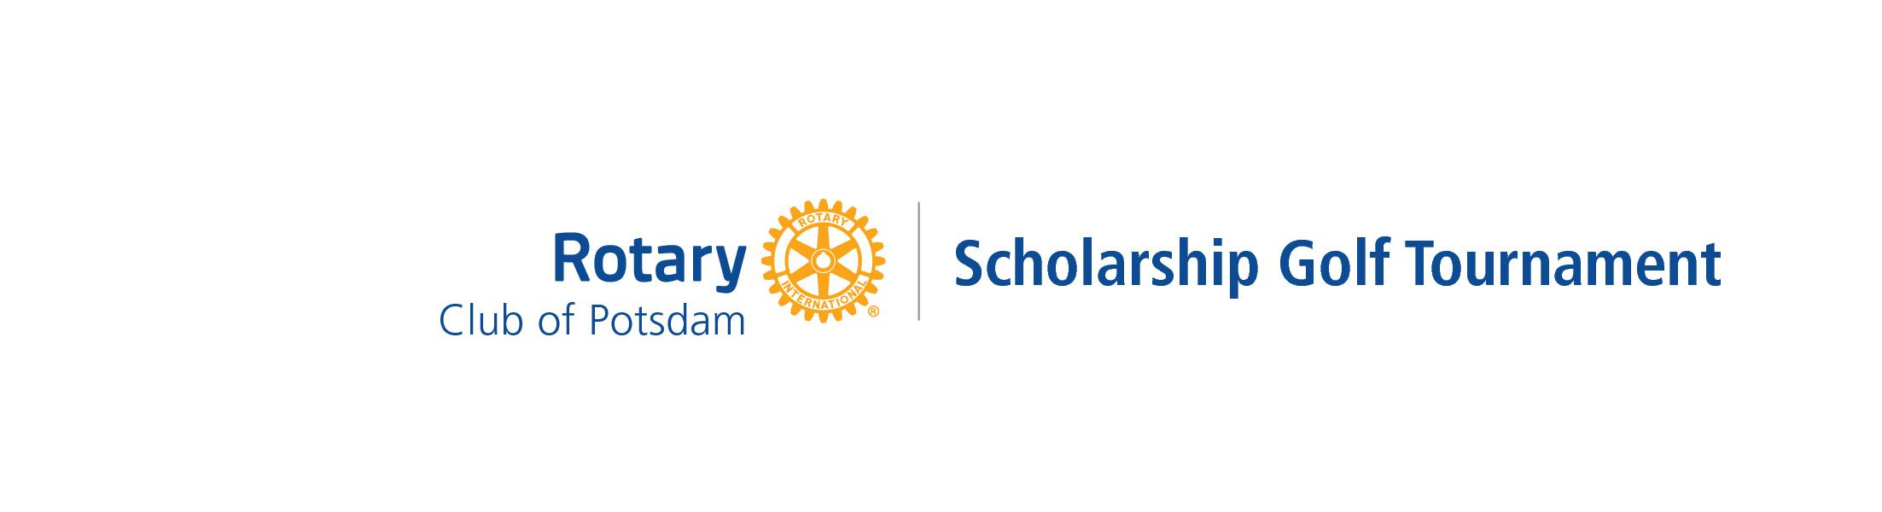

Saturday, May 14, 2022
10 a.m. Shotgun Start

Come Golf with Potsdam Rotary!

$80/person, $320/foursome
Includes Golf, Cart, Lunch, Hors d'oeuvres and Prizes

Proceeds help support:

Potsdam Rotary BOCES College Scholarship Program
Potsdam High School Scholarship
and
Rotary Youth Leadership Award

To register and/or to become a sponsor, please sign up by April 30th at potsdamrotary.org

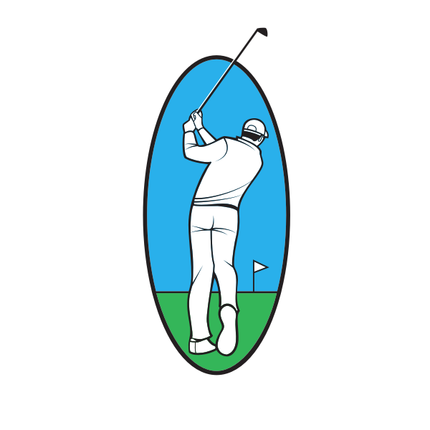
Cash Prizes For:

Captain
&
Crew
Format

Men’s Flight, Women’s Flight, & Mixed Flight

On the course contests:
Longest Drive (men/women), Beat the Pro
Closest to the Pin (men/women)
Closest to the Center Line
Putting, Mulligans, and Skins

golf@potsdamrotary.org
315-244-6652

