Book Launch: "The Promise" (a true story)
AVID Reader bookshop, 193 Boundary Street, West End at 10-11am Saturday 5th November 2022.
Bookings essential to accommodate seating ($10 single, $29.99 family of up to 5).
Booking Link: https://wherethewildthingsare.com.au/events/vicki-bennett-the-promise.
This book launch is a lead-in to the implementation of Terry O’Neill’s (RC Paddington) long term project that involves, amongst other things, the more widespread installation of Rotary’s Teacher-in-a-Box (TIB) book library system in schools in the most remote communities in Papua New Guinea.
I’m sure that this will be an enjoyable event for everyone and should have special significance for anyone who has an affiliation with PNG.
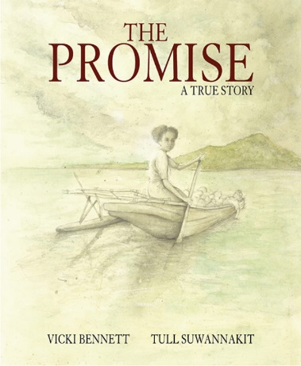

Author Vicki Bennett will speak about her book “The Promise”:

During WW11 RAAF Leading Aircraftsman, Jim Donegan was fished out of Milne Bay and hidden from Japanese patrols. This wounded survivor was cared for by trained mission nurse, Maiogaru Taulebona. In the dead of night, when Donegan was strong enough, Maiogaru hid him in a canoe concealed under a pile of vegetables and paddled him between enemy ships to safety. This was her promise.

