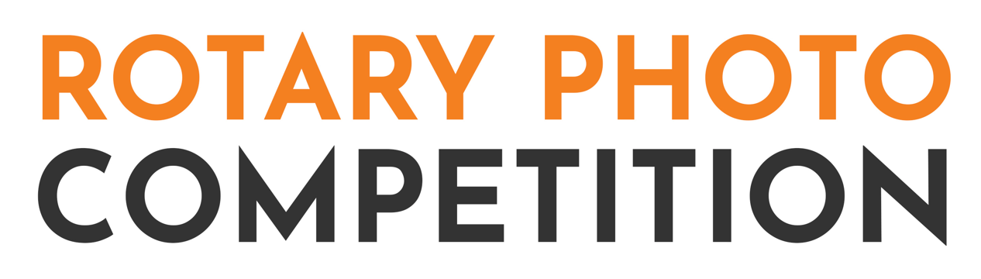Competition FAQ’s
Can I edit my image?
Correcting and enhancing images is ok - but adding a new subject or combining images is not permitted.
What file size and format can my photo be?
Competition entries must be in JPEG file format and less than 10 MB in size.
Can I submit an image taken on my mobile phone?
Yes
Can I submit an image I took over a year ago?
Yes – there is no time limit.
How can I enter the competition?
All entries must be via the form on this webpage. We will not accept entries via email or social media.
How many entries can I submit?
There is no limit.
Who is the competition open to?
Entries are open to amateur photographers only.
How will I know my submission was received?
Once your submission is uploaded and received there will be an automatic reply.
When will the winner be announced?
The winners will be announced I week after the competition closes. They will be contacted via email.
When is the Presentation of Prizes?
Presentation of prizes will be held at Somerset Village Indooroopilly on Thursday 24th November 2022 from 4pm to 6pm. Canapes and drinks will be available and the judges will discuss tips for improving your photography.
For all other enquiries email photo.comp.rotary@gmail.com

