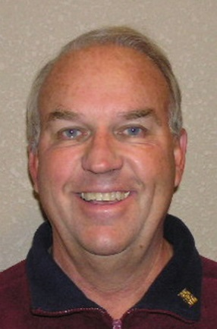

**The Buckeye, and Goodyear White Tanks Rotary Clubs Present**

**The Gary McEachern**

**Memorial Golf Tournament**

**“GARY’S CUP” \***

**PURPOSE:** **TO RAISE FUNDS FOR: (1) LOCAL HIGH SCHOOL - COLLEGE SCHOLARSHIPS; (2) ROTARY INTERACT CLUBS; AND (3) INBOUND AND OUTBOUND ROTARY EXCHANGE STUDENTS.**

**\* To compete for the traveling “Gary’s Cup”, your foursome must contain 4 Rotarians\***

**WHEN: SATURDAY SEPTEMBER 22, 2018**

**WHERE: GOLF CLUB OF ESTRELLA**

**TIME: 6:00 AM CHECK-IN / 7:00 AM SHOTGUN START**

**COST: $75 PER PLAYER / $300 FOURSOME / $100 HOLE SPONSOR**

**INCLUDES GREENS FEES, CART, LUNCH, AND PRIZES !!!**

**TITLE $1,000. INCLUDES: (1) FOURSOME; (2) HOLE SPONSOR SIGNS; AND**

**SPONSOR: (1) BANNER IN THE CHECK-IN AREA**

**CHECKS TO: ROTARY CLUB OF BUCKEYE (for credit card payment, call CHRISTY MCACHRAN 602-989-2409)**

**MAIL TO: P O BOX 594, BUCKEYE AZ 85326**

**INFO AT: JAY BROADBENT – 602-881-9111 (C)**

**DEADLINE: SEPTEMBER 16, 2017 - All monies must be received by start of tournament!**

**If you have any raffle items, please let us know. Let’s do this for Gary !**

HOLE SPONSOR $100 _______________________________________________________________________

TEAM ONLY $300 __________________________________________________________________________

HOLE & TEAM $400 ________________________________________________________________________

PLAYER 1 __________________________________ PLAYER 2 ______________________________________

PLAYER 3 __________________________________ PLAYER 4 _____________________________________

Captain’s name & Phone Number______________________________________________________________ **v.6/23/17**