Caborca Polio Plus Trip
February 14-16, 2020
Now Open for Registration
Registration Deadline Dec. 23, 2019
For additional information and/or to register:
Contact Noel DeSousa (noel.j.desousa@gmail.com)

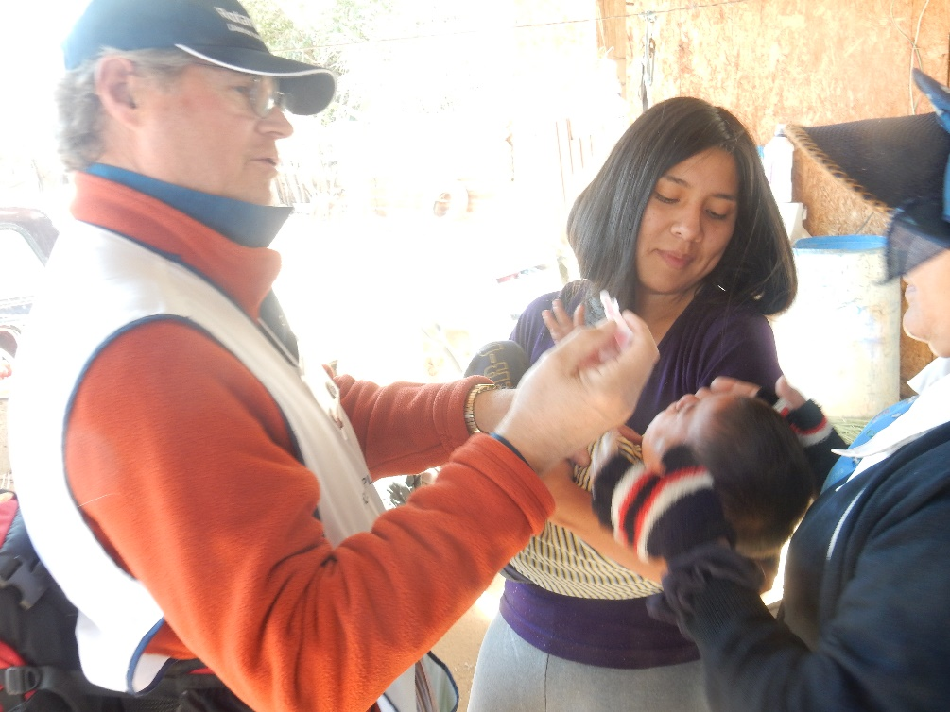
Join us on our yearly bus trip pilgrimage to Caborca, Senora, Mexico as we visit the “ejidos” outside Caborca (villages) to administer the “two drops of life”. If you have talked with anyone who has participated in this event in the past, you'll know that it is a great opportunity to take part in one of the primer projects that Rotary International has undertaken, as well as a chance to get to know Rotarians from other states and districts on both sides of the border, and have LOTS OF FUN!

Basic Guidelines
- All attendees must be a current Rotary, Interact or Roteract member.
- Limited seating requires that a lottery system be used to select participants.
- All attendees must ride the coach bus provided for the trip.
- All individuals attending must have a current valid passport.
- The trip cost will be approximately $175 per person.
For lots of additional details please contact Noel DeSousa >noel.j.desousa@gmail.com<

