Verrado Rotary Foundation atTopgolf
•

You have heard ofTopgolf
but have you experienced the fun?

Verrado Rotary Foundation is a 50l(c)3 corporation sponsoring this fund raising event to benefit the people of Kenya. The Mission is to instill a more informed understanding of cancer and provide needed medical supplies and educational materials/programs for the Green View Academy Orphanage.
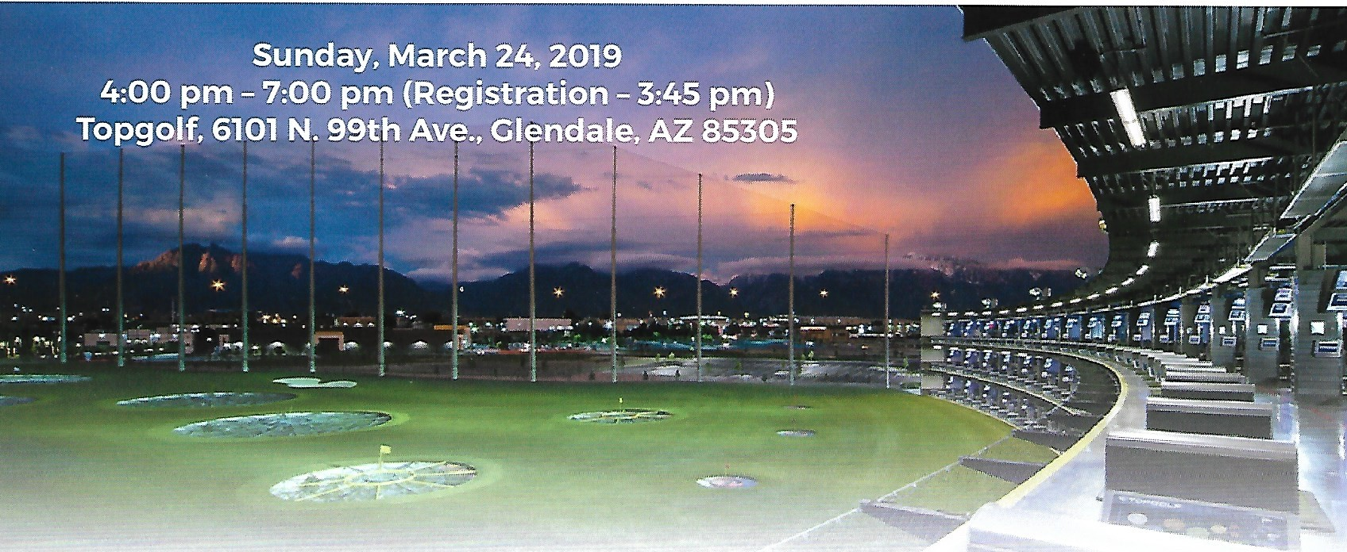
Verrado Rotary Foundation & Topgolfwelcome you to a fun filled event to benefit a most deserving cause.

Your fun filled experience will include the opportunity to enjoy the Topgolf experience while hitting 40 golf shots using your clubs or those provided to earn individual as well as team prizes. Also included is a full Mexican buffet with water & soft drinks. a no host bar. a lifetime membership to Topgolf. and a copy of Rain Delay: Untold Stories from the Legends of Golf by Mark E. Squire. To enhance your fun there will be anopportunity to participate in raffles to win really neat prizes while also being able to be in a 50/50 cash raffle. All proceeds going to benefit the needy people of Kenya and our community.
Sponsorships

Hole in One - $1,500.00 Eagle - $1,000.00
Birdie- $750.00
Team - 6 Members $550.00
Individual - $95.00

(Information on the benefits for each sponsorship level are on the back of this page) Payment - Cash, Check, Credit Card or PayPal to "Verrado Rotary Foundation"

Contact - Doug Bredow at doug.bredow@gmail.com for details and purchase
Verrado Rotary Foundation- "Service Above Self'

REGISTRATION

(You must be registered by March 22nd as walk-ins will not be honored)

Sponsorships -

Hole in One - $1,500 - Team of 6 participants, promotion/logo on bay locator, sponsor provided banner and closed loop promo on 2 big screens in Chairman's Suite, link to your website on the Verrado Rotary FB page, and 6 copies of Rain Delay: Untold Stories From the Legends of Golf by Mark E. Squire

Eagle - $1,000 - Team of 6 participants, promotion/logo on bay locator , sponsor provided banner in Chairman's Suite, link to your website on the Verrado Rotary FB page, and 3 copies of Rain Delay: Untold Stories From the Legends of Golf by Mark E. Squire

Birdie - $750 - Team of 6 participants, promotion/logo on bay locator and in Chairman's Suite

Name (individual/team):-- -- - -- - -- - -- - -- - -- - -- - -- -

Email Address of Primary Cont act: - - - - - - - - - - - - - - - - - - - - - - -

Level of Participation (Sponsor, Team, Individual):- - - - - - - - - - - - - - - - -

Name/Phone Number/Email Address and Zip Code of Team Members:

Thank you for your registration and we look forward to you joining us for all the fun at the Verrado Rotary and Topgolf fund raising event to benefit the people of Kenya and our local community.
Questions....contact: Doug.Bre dow@gmai l.com

