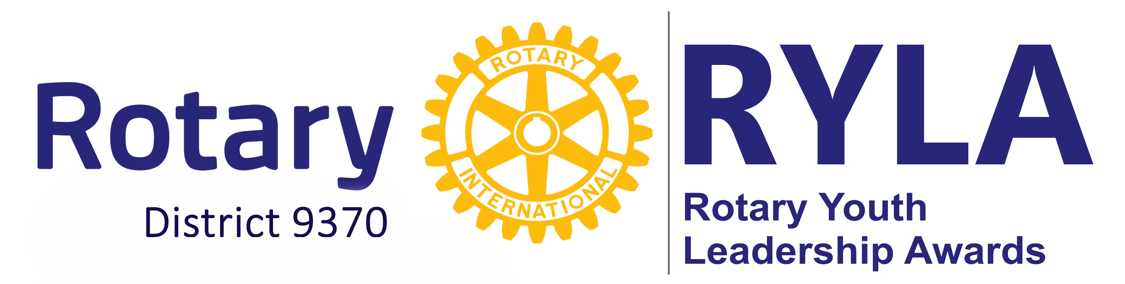
RYLA PERSONAL, INDEMNITY & MEDICAL

INFO FORM

Personal Information
Full Names and Surname: |  |  | Nickname:
Address:
Cell Phone: |  | Gender: M F |  | Current Age: yrs.
Birth date: | ID Number:
E-mail: |  | Camp / Group Name:
Medical and Consent Information
I* (Full Names of Parent / Legal guardian) :
Address:
Phone No.: |  | Email:

I * hereby appoint and authorise the Management and organisers of this Organisation*** to act in my place as guardian with full authority and consent to myself/son/daughter undergoing surgical and or other medical treatment. I* also undertake to pay the cost of such treatment.

I* fully understand and accept that all activities** are undertaken at my/their own risk. I* voluntary assume the risk and am aware that such activities are to take place in the harsh outdoor environment of South Africa, and agree that being such type of event/ activities inherent dangers and certain elements of unpredictability that accompany the excitement contained in activities** all aspects of it.

I* agree to indemnify and keep indemnified the Organisation*** from any claims whatsoever and agree that I* shall not hold the Organisation*** it’s owners, staff, management or any other person forming part of this group/event in any way liable for injuries, mental anguish, or loss of any kind whatsoever or howsoever caused during these activities**. And further agree that I* will abide to all instructions issued by the leadership/facilitator/marshal or manager of this activity**.
I* consent that as a participant in the organisation*** taking part in all activities** I have ensured the participants willingness to participate in all aspects of the activities** offered.
Participant to Sign: _______________, and agreement of guardian if under 21 years of age. ______________

I* also agree to pay for all damages, repairs caused to activity** and organisations*** items caused by negligence or ignorance as by partaking and receiving instruction I am assuming knowledge of operation of such assets / event. The cost of repairs will exclude normal wear and tear of equipment.
I* acknowledge and understand all that is mentioned in this indemnity and that all is at my/our own risk.

Definitions I* meaning myself together with my heirs, executors and administrator, as well as any other person partaking in the event whether individually or as a group.
Activity** meaning; events, courses, studies, adventures, equipment, and all items required for the above mentioned to take place. All activities offered by this organisation*** whether on this or surrounding properties if needed from time to time.
Organisation *** is inclusive of Rotary Int. Rotary club of Ladybrand, RYLA, On Track Adventurers, it’s suppliers, organisers, or any person / company appointed by them to perform a specific duty as required from time to time.

___________________________________ ____________________________
Signature Signature
Adventure participant Parent/ Legal Guardian

Name:_____________________________________ Name:____________________________

Date: ____________________ Date: __________________

Medical Information
Full Names and Surname: |  |  | Blood group
Doctors Name: |  | Dr Tel No:
Medical Aid | Med Aid Plan / scheme
Medical Aid Membership Number

The information provided in this form is required in order to provide appropriate medical help and support if required.
Please answer questions fully and honestly. If at the start of the course it is found that the information has not been given correctly, and forms not filled in and signed, Life Adventures reserves the right to refuse participation. If you are concerned about your physical suitability for the course, please seek advice from your doctor and inform us accordingly in writing.

Please provide details if ever had:

- Any conditions of the Heart, lungs, nervous, digestive, bladder, urinary, blood and abdomen
____________________________________________________________________________

- Diabetes, Epilepsy, Psychiatric, fainting, migraines and Athma_______________________________________________________________________
- Allergies – Food, hay fever, insects, medicines or other________________________________________________________________________

- Broken bones, muscle tears, ligament damages, operations____________________________________________________________________

- Any diagnosed conditions, diseases or injections ___________________________________

- Dietary requirements (Surcharge is applicable) ____________________________________________________________________________

- Can you swim 50 metres in light clothing? ___________________________________

- Are you currently taking any medication? What and why?______________________________

____________________________________________________________________________

If there are any changes to the above, you MUST inform the Organisation*** immediately.
I declare ALL Medical information on this form is true and have not withheld any relevant information

Participants Name:________________________ Participants signature:________________________

__________________________________ _____________________________
Signature of Parent/ Legal Guardian if Under 21 years of age. Date

