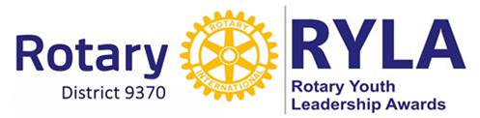

INVEST IN OUR YOUTH – MOULD TOMORROWS LEADERS

**Dear club President, Secretary, Youth Organiser, Fellow Rotarians**

The **Rotary Club of Ladybrand** has pleasure in hosting RYLA 2019 from **Thursday 28th Feb to Sunday**

**3rd March 2019** at *On Track Adventures*, situated on a farm close to Hobhouse in the Free State. The

weekend promises to be a time of personal growth and development, leadership training and a whole

lot of fun for those who are able to attend.



|  |
| --- |
| **COST: The cost of the camp is R1250 per delegate and includes accommodation,**  **all meals, a host of activities and guest speakers.** |

We hope that as many clubs as possible in the area will join us at the RYLA camp. *RYLA is a service*

*That Rotary provides to our communities and we encourage your Club to again participate in this*

*Important project.* ***We cannot succeed without your club’s support.***

**RYLA emphasises leadership, citizenship, and personal growth and aims to:**

* Demonstrate Rotary’s respect and concern for youth
* Provide an effective training experience for selected youth and potential leaders
* Encourage leadership of youth by youth
* Recognise publicly young people who are rendering service to their communities



**Delegates [boys and girls] must meet the following criteria:**

* Be in grade 10 or 11
* Be between 15 and 17 years of age
* **Not** have attended a RYLA camp previously

Places will be allocated on a first come first served basis.

**Rotary Clubs are welcome to send as many delegates as they wish.**

We must however stress that we cannot have clubs advising that they will be sending a certain number

of attendees and then not send any, or advising a change in number in the last week before the camp.

It not only makes it very difficult for us as organisers but could prevent the chances of others unnecessarily

being turned away.

**Clubs are asked to register students by 14th of February to ensure a place in the camp.**

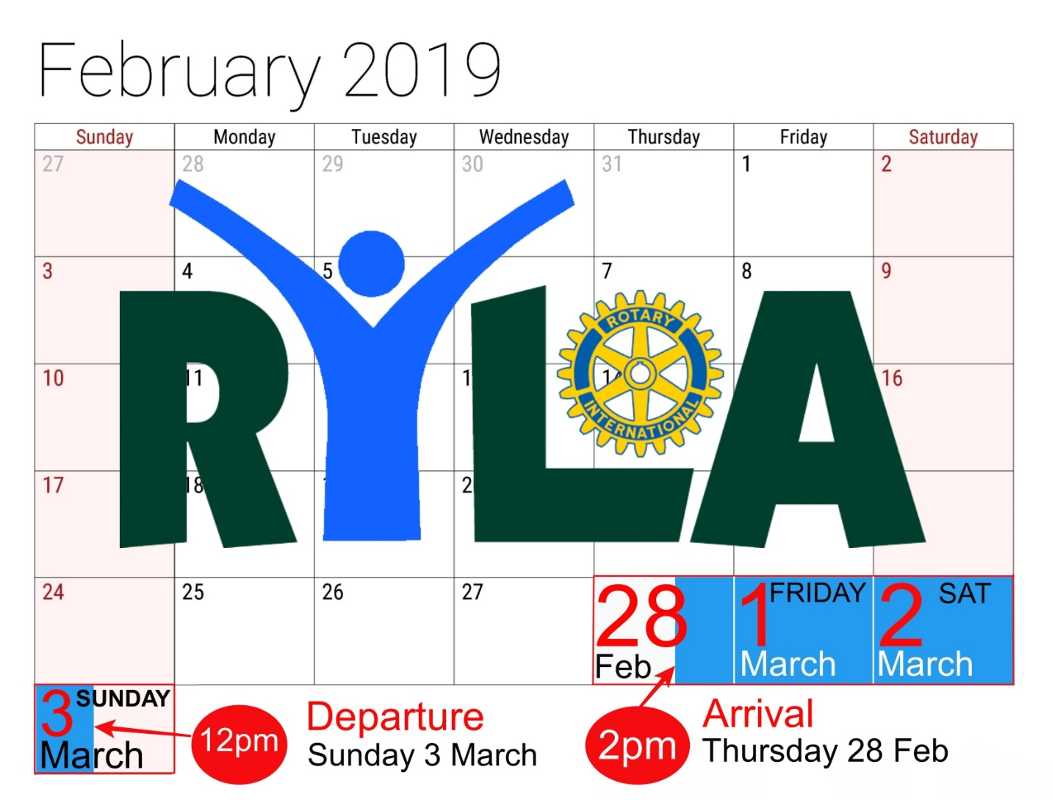Course dates:
Thurs 28 Feb to Sunday 3 March
Registration Deadline:
14 February ‘19


**Please consider the following:**

1. RYLA is a Rotary initiative and **MUST please be coordinated by Rotary clubs** and not left to

the schools or parents to make the arrangements.

1. Please attempt to maintain a balance between boys and girls.
2. All application forms MUST be checked by the responsible person in your club **[please let us**

**have the person’s name and contacts]** to ensure that all relevant information is included

and thereafter the documentation should be submitted to:

[Rotary Club of Ladybrand:
Len Cousins: megaworld@vodamail.co.za
Liezel Scheepers: 082 847 2103
](mailto:megaworld@vodamail.co.za)              Submit documentation to:

PAYMENTS: Cheques and EFT’s [No cash deposits please] should be made payable to
The Rotary Club of Ladybrand and paid into the account listed below.
REFERENCE:
Please indicate the name of your club and RYLA 2019 
on the deposit slip/EFT payment.

 



One of the 3 participating teams - 2018PLEASE NOTE: Rotary clubs will be responsible to cover all costs in the event of last minute cancellations or non-attendance, if cancellations are not made
in writing within 15 days of the camp. [Latest 13 Feb 2019]



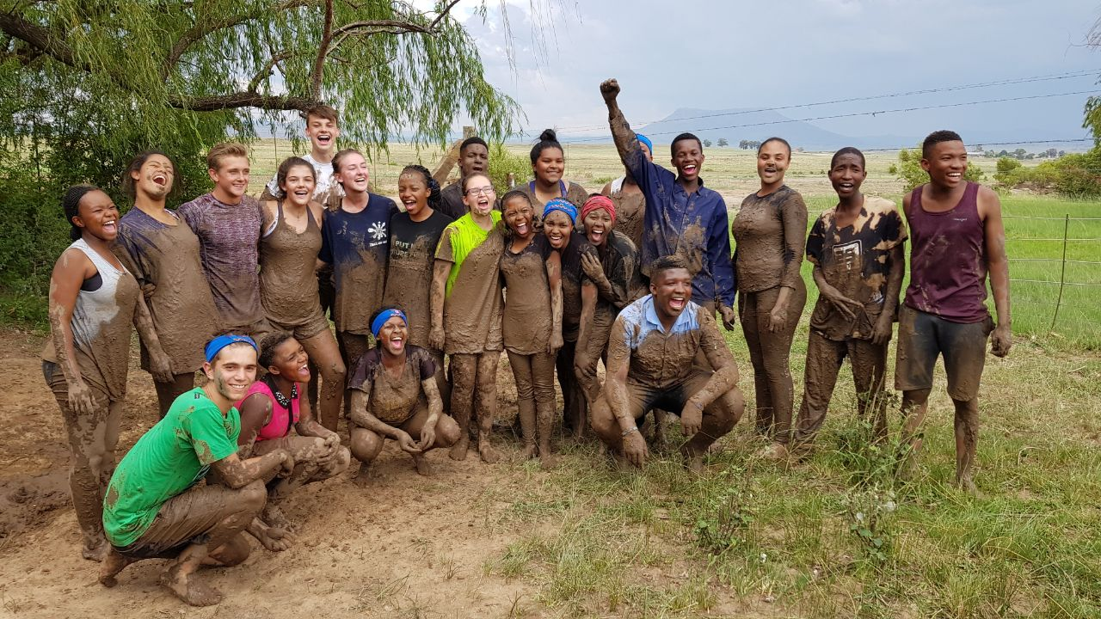

Schools in your area must please be notified of the RYLA camp and you are requested to follow up

with them for the selection of potential participants. Schools will be testing soon so please don’t hesitate

to contact them ASAP.

Yours in Rotary



***Attachments:***

* *1. RYLA Application form 2019*
* *2. RYLA Personal, Indemnity and Medical information forms*
* *3. What to bring*
* *4. RYLA Payment advice form*