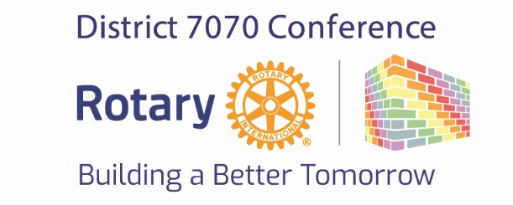
Oct 20th to the 22nd, 2023
Townplace Suites / Courtyard by Marriott Hotel, Oshawa, Ontario

Program at a Glance
 | Friday, Oct 20th, 2023
2pm to 8pm | Registration / Help Desk
1pm to 4pm | Harmony Creek Golf  OPG Tour  Nature/birding walk with Joe Solway at Second Marsh
6pm to 9pm | House of Friendship Reception- Foyer
8:30pm to ??? | Hospitality Suites  1 Bowmanville/Courtice/Oshawa/Oshawa Parkwood  2 Virginia O’Reilly – Toronto East  3 Cobourg
 | Saturday, Oct 21st, 2023
7:00am to 5:30pm | House of Friendship
7:00am to 4pm | Registration / Help Desk
7:00am to 8:30am | Continental Breakfast - Foyer
8:15 to 9am | Opening Ceremonies- Main Ballroom  Opening remarks – Peter Hernandez  Land Acknowledgement- Shauna Moore  O’Canada-  Youth Exchange Flags-  Introduce Special Guests -Peter Hernandez  Greetings and welcome remarks - DG John Burns
9:00am to 9:15am | Welcome Video by Gordon McInally
9:15am to 10:15am | Keynote Speaker 1  OPG – SMR Small Modular Reactor Development and Benefits
10:15am to 10:45am | Refreshment Break
10:45am - 11:45 am | Keynote Speaker 2  Luke Vostermans/Linda Ryan – Empowering Women/Roll a Hippo
11:45 to 12 noon | House of Friendship Break- Foyer
Noon to 1:00pm | Buffet Lunch- Foyer and Main Ballroom
Noon to 1:00pm | VIP Lunch for Speakers, Sponsors with Rotary Leaders / Committee

 | Afternoon Breakouts
 | Ballroom A | Ballroom B | Ballroom C
1:15 to 2:15pm  Session #1 | A model of community engagement for crisis response  Dr. Sayra Cristancho | HIP/Mattawa  John Currie | Session 1  Matangwe, Kenya and Grants  Dr. Ruth Mathieson
2:15pm to 2:25pm | Transition time | Transition time | Transition time
2:25pm to 3:25pm  Session #2 | Mental Health and Wellness Team | A model of community engagement for crisis response  Dr. Sayra Cristancho | Session 2  Water Harvesting for Sustainability, a promising model for Africa  Richard Mewhinney
3:25pm to 3:35pm | Transition time | Transition time | Transition time
3:35pm to 4:35pm  Session #3 | Mental Health and Wellness Team | HIP/Mattawa  John Currie | Session 3  Clean Water – The Power to Change Lives in SE Asia  Steve Rutledge
4:35pm to 5:35pm | House of Friendship- Foyer
6:00pm to 6:30pm | Cocktail Half Hour
6:30pm to 8.00pm | Gala Dinner- MC- Peter Hernandez  Invocation – Steve Burnett  Toast – King/Canada/Rotary International - Steve Burnett
7.45pm to 8:30pm | Peter Hernandez & Youth Exchange Students- Fireside Chat during dessert and coffee
8:30pm to 10:00pm | Entertainment  The Acoustic Band
 | Sunday, Oct 22nd, 2023
7:30am to Noon | Registration / Help Desk
7:30am to 8:30am | Continental Breakfast- Foyer
8:45am to 9am | Welcome Main Ballroom MC- Peter Hernandez  Land Acknowledgement- Shauna Moore
9am to 10.00am | Bob Wallace and Ted Morrison on Rotary Foundation  What has been achieved and what we will tackle in the future
10:00am to 10:15am | Refreshment Break
10:15am to 11.30am | We are Awesome  A presentation from each Region on Major successes and future plans
11:30am to 12:15pm | Closing Ceremonies  Closing Remarks – Peter Hernandez  Intro to Fall 2024 District Conference- Virginia O’Reilly  DG John Burns Conference Wrap up
12:15pm | Buffet Lunch

