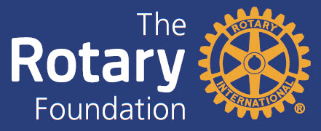

Seminar for members of Rotary and Rotaract Clubs in D7070

Saturday November 19, 2022
Oshawa & District Shrine Hall
1626 Simcoe St N, Oshawa

Program

08.30 Registration
Coffee/Tea
09.00 Welcome
DG Iosif Ciosa
Participants – Who Am I?
09.20 The Rotary Foundation; Mission and Funding
Bob Wallace
09.45 The SHARE program – How the District is spending the Rotary Foundation funds
Lars Henriksson

10.10 Coffee Break

10.30 Polio Plus Up-date – What Is Happening?
Dr. Bob Scott
10.50 Global Grant project presentation
Karantina Public Hospital - Paediatric Ward and Operating Theater Equipment
Steve Rutledge
11.15 District Grant project presentation
Durham Region Kids Safety Village,
Lennis Trotter

11.40 Lunch

12.15 Project Fair
Clubs are invited to present Global Grant projects/ideas where they are looking for support/sponsors
(Pls, contact Lars Henriksson pdglars.henriksson@gmail.com if you want to make a presentation)
13.30 ` Wrap up & Adjournment

- Each Rotary and Rotaract Club is encouraged to send two members
- Club members who attend the full program will count for their respective Clubs towards the Rotary Foundation Qualification Rotary years 2022-23 and 2023-24
- On-line qualification modules will be available in March 2023 for the 2023-24 Rotary year as an alternative
- Free of charge
.
Register on www.rotary7070.org

