RLI PROPOSED PROGRAM 2020 - 2021

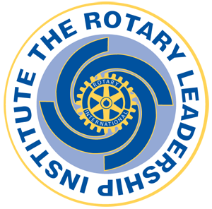Due to Covid-19, we need to move our RLI Program to a virtual format using
videoconferencing. Based on practices from other Rotary Districts, a suggested format for RLI
is to conduct the courses during the evenings over multiple weeks; this format will allow
Rotarians to complete all three levels after 9 weeks.

Each weeknight would consist of a minimum of 2 RLI courses. The format could be:

5:00 pm - 5:10 pm Welcome & General Introductions
5:10 pm - 5:45 pm RLI Course #1 with Facilitator #1 (35 minutes)
5:45 pm - 6:20 pm RLI Course #2 with Facilitator #2 (35 minutes)
6:20 pm - 6:30 pm Debrief & Close

Fees: $50 per person optional donation to RI Foundation

Meeting: Zoom video-conference
Number of Participants: Up to 15+

NOTE: RLI content will need to be adjusted for a virtual meeting format to facilitate and
encourage general ‘interaction’ among participants.

PART IRLI CourseFacilitators

Wednesday November 4, My Leadership in RotarySaleem Kassum
2020
My Rotary Leadership*Lynda Ryder

Wednesday, November 11, Ethics and Vocational ServiceBob Wallace
2020
Foundation 1: Our Foundation*Ted Morrison

Wednesday, November 18, Engaging MembersTBD
2020
Creating Service ProjectsDave Andrews

*Option: RLI participants can attend District ‘Tuesday Talk’ in October and November

PART IIRLI CourseFacilitators

Wednesday, January 13, Rotary OpportunitiesBob Wallace
2021
Effective Leadership Strategies Lynda Ryder

Wednesday, January 20, Attracting MembersPauline Lyons
2021
Club CommunicationDave Andrews

Wednesday, January 27, Team BuildingTBD
2021
Foundation II: Targeted ServiceTed Morrison

Page 12 of
PART IIIRLI CourseFacilitators

Wednesday, February 10, Strategic PlanningTBD
2021

Wednesday, February 17, Foundation II: Targeted ServiceLars Henriksson
2021
Public Image & Public RelationsDave Andrews

Wednesday, February 24, Building a Stronger ClubVirginia O’Reilly
2021
Making a DifferenceSusan Hunter

Graduation Ceremony with DG Mark Susan Hunter
Chipman!

Page 22 of

