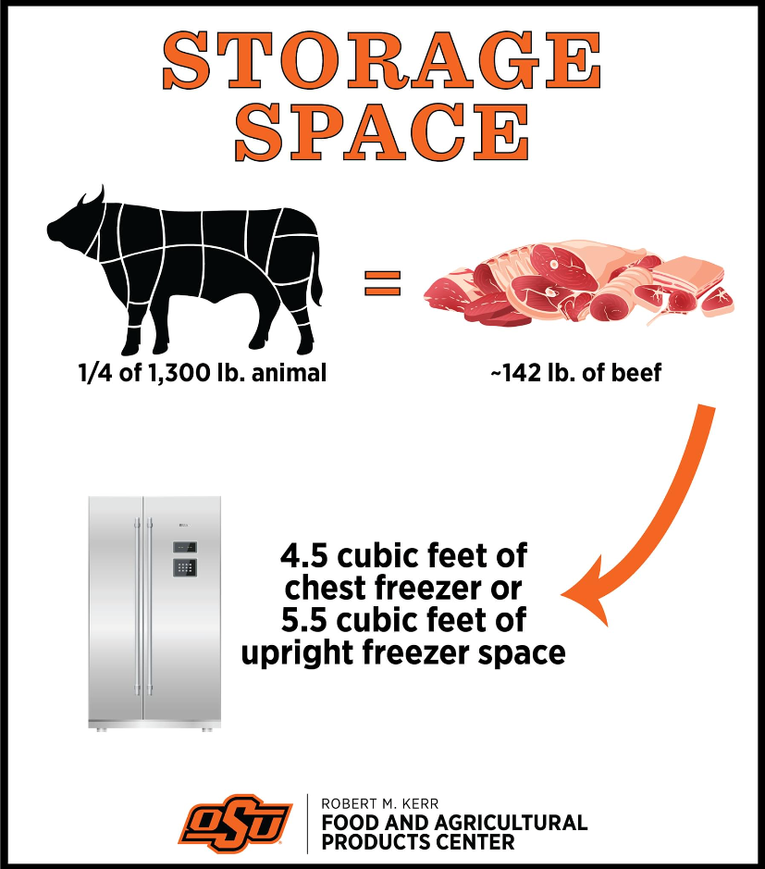

**Contact any Rotary Member or Jessica Dvorak for tickets.  
Call 405-388-4161 for more information.**

**Drawing will be held on February 1st**

**Tickets are $5.00 each   
or 5 for $20.00**

**Need not be present to win  
  
All proceeds will go to The Perry Rotary Club’s Service Projects.**

**WIN A QUARTER OF BEEF!!**

**\* PROCESSING COSTS INCLUDED \***

Fundraiser

Perry