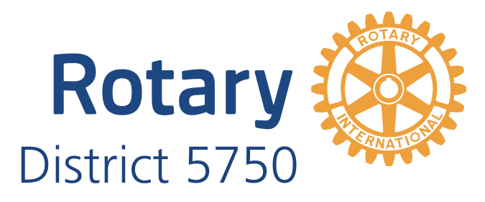
The Rotary Leadership Institute
Saturday, February 25, 2023
9:00 AM to 3:00 PM
at Harbor Chase, 10801 S. May Ave, Oklahoma City 73170

AGENDA

9:00 AM to 9:25 AM Introductions
Each person has 60 seconds

9:25 AM to 10:00 AM Club Communications
Deena Fisher, District Governor, Woodward Rotary 580-334-3976

10:00 AM to 10:35 AM Team Building/PETS
Deena Fisher, District Governor, Woodward Rotary 580-334-3976
Jeanean Yanish Jones, DGE, Rotary Club of Oklahoma City 405-694-6154

10:35 AM to 10:45 AM Break

10:45 AM to 11:20 AM Foundation II: Targeted Service
Mark White, West Rotary 405 – 412-6845

11:20 AM to 11:55 PM Strategic Planning
Mark White, West Rotary 405 – 412-6845

11:55 PM to 12:15 PM Lunch will be served or we will go through a line, get our plates and return. This is a working lunch.

12:15 PM to 12:0 PM Foundation III – International Service
Chuck Musgrave, PDG Edmond Rotary 405 – 326 – 6408

12:50 PM to 1:25 PM Public Image & Public Relations
Megan Law, PDG, Rotary Club of Oklahoma City 405-590-1378

1:25 PM to 1:40 PM Break

1:40 PM to 2:15 PM Building A Stronger Club
Megan Law, PDG, Rotary Club of Oklahoma City 405-590-1378

2:15 PM to 2:50 PM Making a Difference
Chuck Musgrave, PDG Edmond Rotary 405 – 326 – 6408

3:00 PM Adjourn

Please RSVP by Friday, February 17th
to Jack Werner at 405-406-1790

Mid-America Presidents Elect Training Seminar

Mar 23, 2023 6:00 PM – Mar 25, 2023 2:00 PM
https://midamericapets.org/
Holiday Inn Hotel & Conference Center
1500 South 48th St
Springdale, AR 72762

Thank you for your commitment to Rotary!

Jack L. Werner, DGN
SOKC Rotary 405-406-1790

