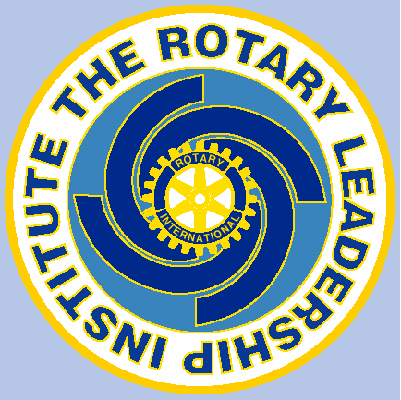
Rotary Leadership Institute (RLI)

What is RLI?
The Rotary Leadership Institute is an international network of Rotary and provides a series of fast-paced, interactive, three one-day sessions designed to refine the leadership skills of Rotarians and increase their knowledge of Rotary. The Rotary Leadership Institute (RLI) believes that excellent club leadership is essential to the future of Rotary in a complex and fast changing world.

Courses are fun, topical, interactive, and geared towards the modern Rotarian’s busy schedule.

Who is the course for?
Most Rotarians have not been exposed to the great scope of Rotary around the world and may have not considered what leadership skills are necessary to move Rotary forward. Rotary clubs are encouraged to select several candidates each year for the RLI. Participants return to their clubs with enthusiasm, new contacts, fresh ideas, an increased understanding of their potential as Rotarians, and with the valuable skills for their potential leadership in the club.

Topics include:

- My Rotary World
- Creative Service Projects
- Analysing a Rotary Club
- Building a Stronger Club
- Club Communications
- Vocational Service - Ethics
- Leadership and Team Building
- Effective Leadership Strategies
- Membership - Attracting, engaging and retaining members.
- The Rotary Foundation
- International Service
- Public Image & Public Relations
- Making a Difference

Benefits of attending?
Some comments from previous District 9820 participants:

- “Very well-presented course with topical and relevant information and practical ways to improve as a Rotarian”.
- “An enjoyable day of expanding knowledge of Rotary Leadership within Rotary”.
- “This is a valuable exercise I think for all board members and potential incoming board members”.
- “All good value as a newer member to Rotary. An informative day”.
- “As with session one the information outlined in the current session was both highly beneficial and valuable”.
- Great three days of learning and networking.
- Assisted in clarifying the complicated, cohesive range of activities and objectives with which rotary in involved.
- The leadership training session has been a regarding experience. To hear and share ideas from different perspectives and length of service. The level of workshops was excellent for this session. Overall there should be more of this and I will encourage others to attend next year.
- Excellent presentations by all facilitators. Good pace and good topics covered for us to learn. Very worthwhile experience
- A fantastic program which should become compulsory part of a member’s life in Rotary.

Course Dates (All Saturdays)

Session 1 | Sat 9 February 2019 | 9.00am to 4.00pm
Session 2 | Sat 9 March 2019 | 9.00am to 4.00pm
Session 3 | Sat 13 April 2019 | 9.00am to 4.00pm

Cost:
The cost is $75 per head for materials and catering. This is normally paid by clubs.

Venues:
Leongatha RSL
Corner Smith Street and Michael Place
Leongatha, Victoria, 3953

For further information or nomination form please contact:

Tim Wills (RLI Facilitator)
M: 0490 849 466
E: publicimage@district9820.org

