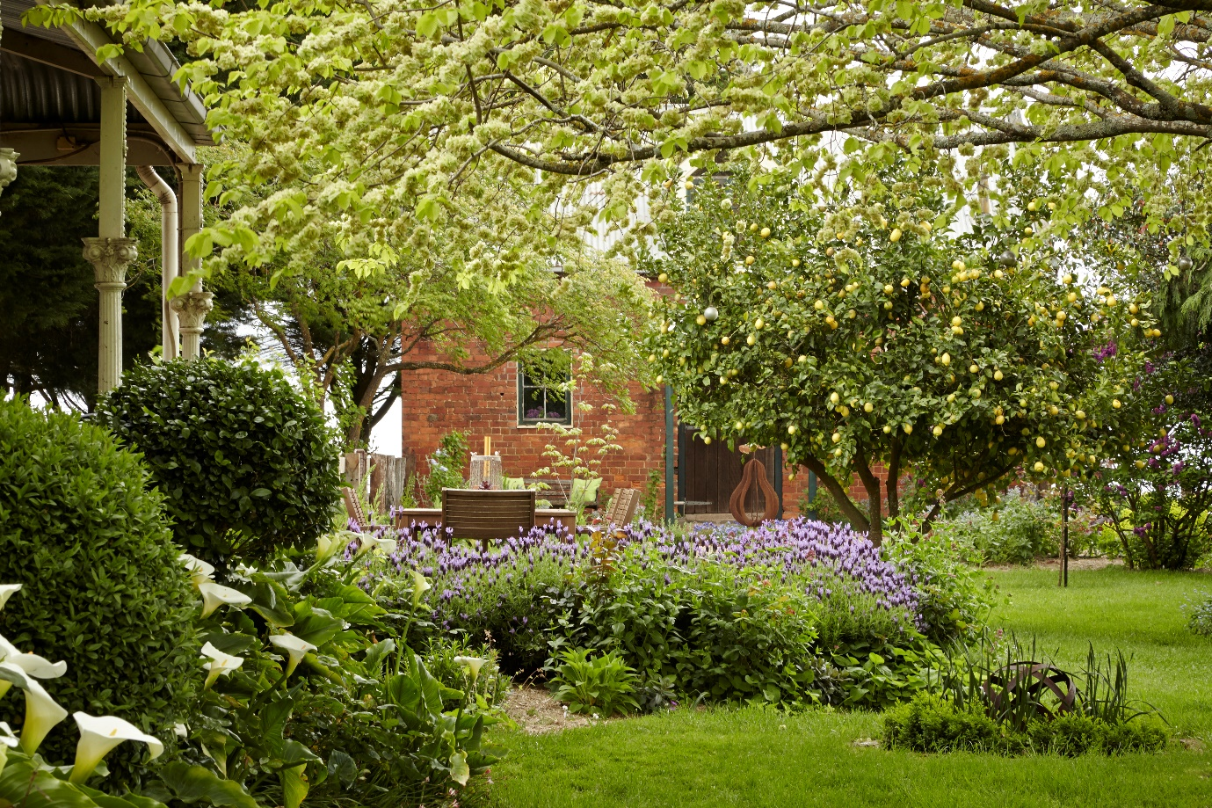
Garden Party High Tea Fundraiser
‘Hedgerow’, 275 Kingston Road, Kingston on Saturday 17th November 2pm -5pm
Alfredton Rotary and Uniting Ballarat are working together in aid of expanding Breezeway’s Meal program, Skills training and Extreme weather accommodation for homeless rough sleepers.
On arrival guests will receive a glass of bubbles and are encouraged to meander around the garden ending up in a luxury marquee where a sumptuous high tea will be served.
Tickets $50 per person and available by contacting Jill Oliver on 0407333410 or calling into Blue Artz, Gallery & Café, 1039 Howitt Street, Wendouree.
Mon-Friday 9:30am-3:30pm

