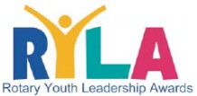
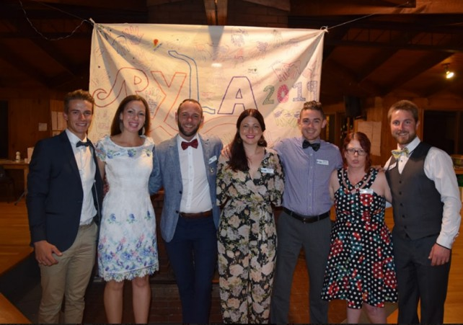

IT IS 60 YEARS SINCE THE FIRST RYLA CAMP WAS HELD IN THE WORLD
You are invited back to Camp Kangaroobie on Saturday 30 November 2019
to help celebrate RYLA’s birthday
Get together with your fellow RYLArians to celebrate your experiences and memories
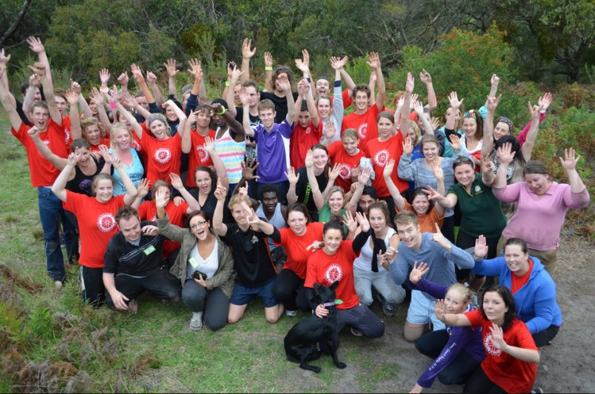
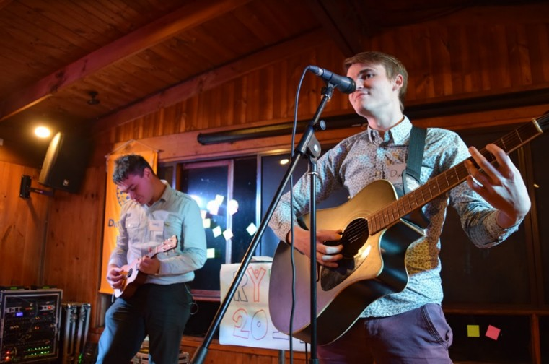

You are an important part of the wonderful RYLA story in Rotary District 9780 so come back and share your journey from your RYLA Camp to today with others who have travelled similar journeys

Past RYLArians are encouraged to bring along any photos or other memorabilia to share in the celebration
- Bring back some wonderful memories and catch up with old friends
- See memorabilia, photos and banners from past RYLA Camps
- Meet past and present members of the RYLA Leadership Team
- Reconnect with RYLA content by participating in a mini RYLA session with members of our District Leadership Team (optional)
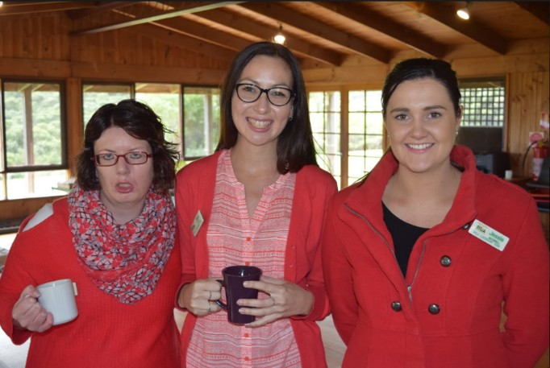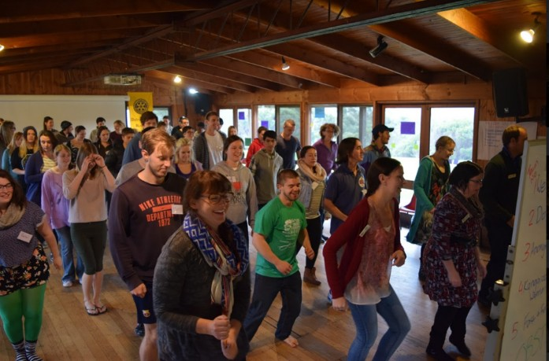

TIME: 11.30 AM – 3.30PM, BBQ LUNCH $22.00 PER HEAD – PARTNERS WELCOME
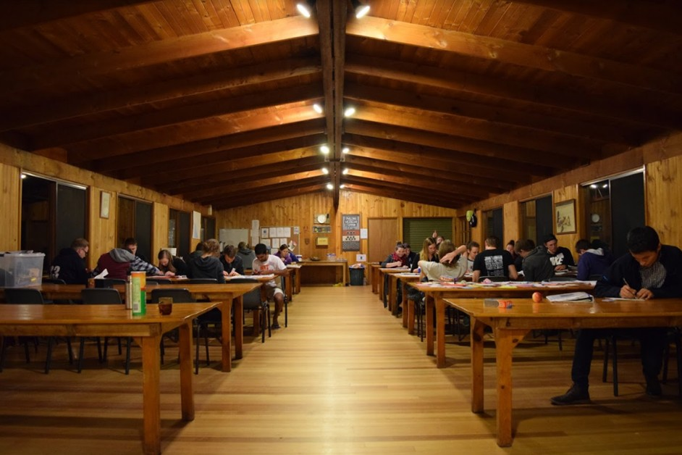

CAMP KANGAROOBIE
Great Ocean Road, Princetown Victoria 3269

Name:
Email:
Phone:

Year you attended RYLA:
Sponsoring Rotary Club when you participated in RYLA:

Number of guests attending including yourself:
Any Special Dietary Requirements:

PLEASE PAY BY EFT TO THE FOLLOWING BSB: 633000
ACC: 163 588 809
REF: {Your Surname.Initial of first name ie SmithJ}

RSVP NO LATER THAN 5.00PM SUNDAY 24 NOVEMBER
PLEASE SCAN AND EMAIL REGISTRATION FORM TO THE FOLLOWING EMAIL ADDRESS
Ckinley44@yahoo.com
Ph.: 0407 561 226 – FOR FURTHER INQUIRIES

