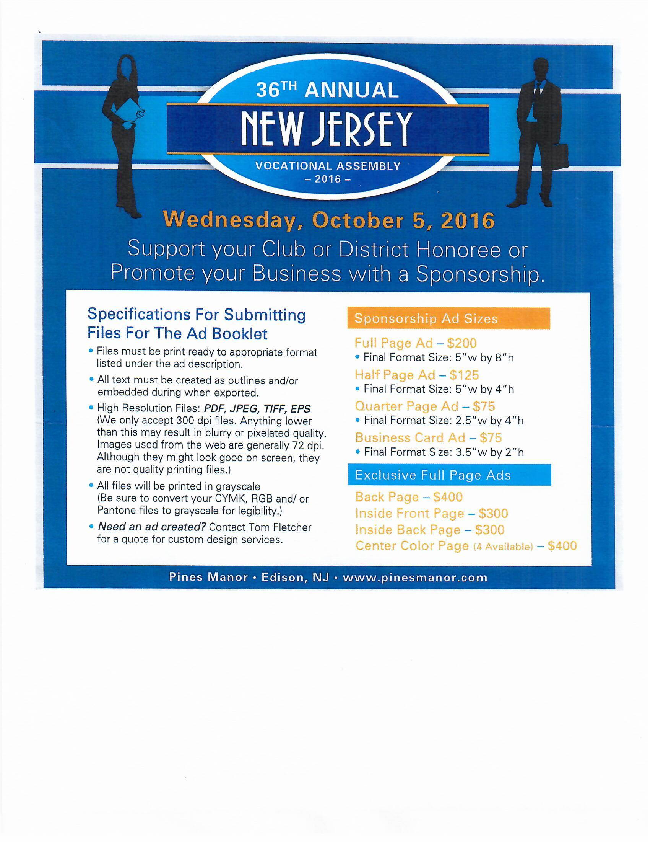**Rotary District 7470**

**Name _____________________ Business ______________________**

**Address ___________________ City, State, Zip _________________**

**e-mail (required) _____________ Repeat Last Ad New Ad**

**Phone Number _________________ Fax _____________________________**

**Size Ad _______________________ Amount $__________Check# _______**

**Rotary Club of _________________ District Number __________________**

**Checks Payable to NJVA sent to: John Wilson, 10 Corn Hill Drive, Morristown, NJ**

**Artwork for Ads Should Be High Resolution**

**Art sent to** [**tom.fletcher@postnet.com**](mailto:tom.fletcher@postnet.com) **Deadline 9/6/16**