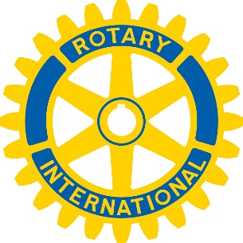
Rotary Seminar/Training
2017 PETS is sponsoring a FREE
Seminar Training - March 23, 2017
Available to all Rotarians
Three Topics to be Covered
Membership Development – The Rotary Foundation
Resources available for Rotary International

When: March 23, 2017
2:00 pm to 5:00 pm

Where: Hanover Marriott
1401 NJ Route 10, Whippany, NJ

Cost: No Cost (advance registration required)
Register on PETS Mid Northeast website at www.petsmidnortheast.org
Or click direct registration link below https://www.crsadmin.com/EventPortal/Registrations/PublicFill/EventPublicFill.aspx?evtid=26026f75-8713-49bb-8dc2-89cb64c076f9
$25.00 for walk-ins

3 Topics: Rotary International
Rotary International - How it works – resources available
Facilitator: Kaitlin Bautz, RI staff (Club and District Services)
The Rotary Foundation
Do you really understand the Rotary Foundation? Learn about grants, get you questions answered, resources, methods of giving, recognitions and more
Facilitators: Chris Boyce, (Foundation staff, online)
PDG Drew Kessler – Onsite
Membership Development
How to grow your club – Attracting and Retaining members
Rotary’s new levels of flexibility for your clubs - Case studies of success
Facilitators: PDG Barry Kroll, District 7470
PDG Arnie Quaranta Jr., District 7255

Optional Enjoy dinner, fellowship, entertainment
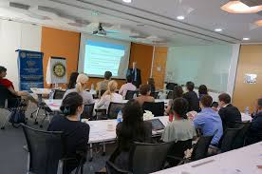
Dinner: 5:30 to 8:30 pm
(Pizza, salad, beer and wine)
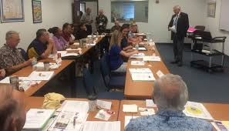
Donation for optional dinner $20.00 cash only

