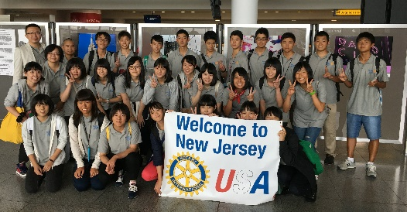
You’re Invited to the
Rotary Short Term Youth Exchange Farewell Party

When: Tuesday, August 15, 2017
Where: Hanover Manor
16 Eagle Rock Avenue
East Hanover, NJ 07936
Time: 6:00 pm Meet and Greet
7:00 pm Dinner and Program
Cost: Host families & American students free
Other Guests $40.00
RSVP: Jim Allison at JRA188@aol.com by 8/11/17
Include name and number of people
Pay: Pay at the door; cash or check only (payable to Rotary District Foundation 7470)
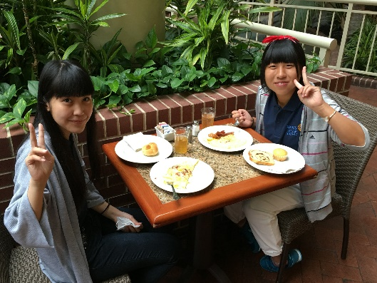
Please join the celebration and help us say farewell to our Japanese students and leaders. There will be good food, a short program and great entertainment!

