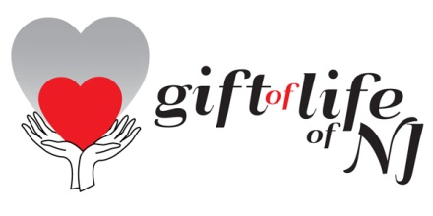
Dear Friend of Gift of Life,
Well, it’s that time again……time to bring all of you up to date on our various
activities and plans……time to fill you in on all we’ve been up to over the past
year and share what we are looking forward to accomplishing in the current year.

As is customary, we are doing this at our ANNUAL MEETING DINNER.

Our Friends & Supporters will gather for cocktails, dinner and an informative evening, so please join us on:

Monday, September 26th
at
The Ukrainian American Cultural Center of NJ

6:00PM Cocktails (Cash Bar)
7:00PM Dinner and Program
$35 per person

Featuring our guest speaker,

Ms. Barbara Ciconte,
President, Take Heart Association Project, USA

Ms. Ciconte will share her experiences of helping to save children from Kenya who suffer from congenital heart disease; children who would otherwise perish without your support.

Join us for a moving evening as you learn how your dollars are helping us to save children around the world……..one little heart at a time!

Please R.S.V.P. to Laurie Braun via email: lauriebraun@optonline.net or via cell (973) 713-9080. Checks should be mailed along with the names of attendees and/or club members by Wednesday, September 21st to:

Gift of Life Inc. of NJ
P O Box 25
Morris Plains, NJ 07950

P.S. This event has become an opportunity for your club to make its annual
contribution to Gift of Life and be publicly acknowledged. If you would
care to do so, please let us know and we will include you in our program.

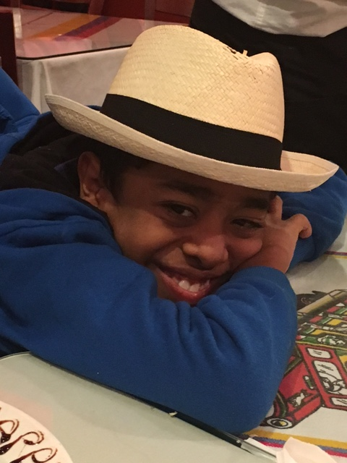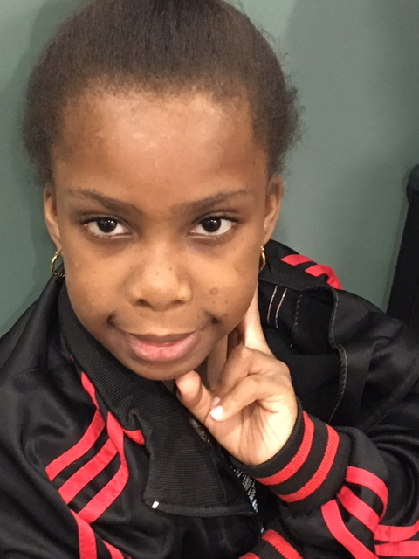
Joseph, Panama January 20116 Darineyka, Panama August 2016
Sponsored by Morris Plains RC Sponsored by Montville RC

