Membership Program
Back to Basics – Sault Canada
District Membership Chair, Orville Crain
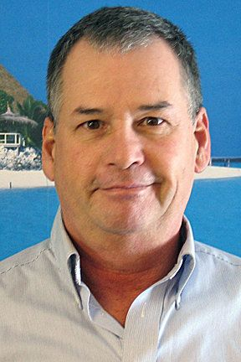

Barry Rassin, our current Rotary President, in the August Rotarian (in part) said, “… we are a membership organization”, and “… put membership first”.
This session will maintain emphasis on membership, retention, and recruitment. We will discuss encouragement, welcoming new members, orientation (fireside chats), new member get together sessions, and committee engagement.
Participants will hear leaders offer their elevator pitch in two minutes and then participants will be asked to give theirs if they so choose. The emphasis will be on asking and keeping membership top of mind – putting membership first!
This session will also cover some of the new RI materials that have recently been issued.
And finally participants will be asked how they have recruited new people. Even more we will ask you for one minute on specifically how your last (or any member) got to be a member of your club.
This program will be hosted by Orville Crain – District membership chair and a future draft pick!
This program will be fun and informative with a goal of helping small clubs get one net new member, most clubs getting at least two new members, and the large clubs getting three new members.

