The Rotary Foundation: The Engine Behind Rotarians Doing Good in the World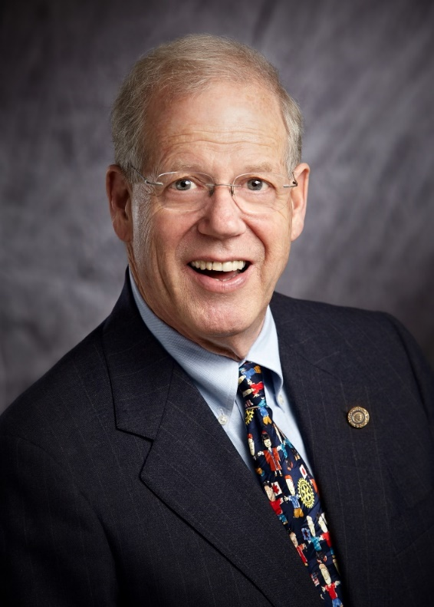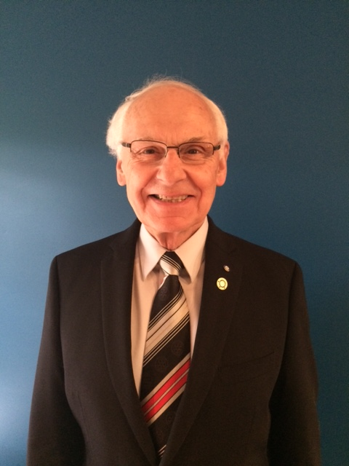

Presented by PDG, Al Bonney and PDG, Gernot Runschke

I received lots of feedback after my 40 club visits last year that an overview of the unique and valuable resources and benefits that The Rotary Foundation (TRF) brings to Rotarians would be a welcome topic. Only Rotarians can take advantage of the opportunities that The Rotary Foundation brings to the table so a solid understanding of the range of opportunities provided makes it easier to take advantage of them in ways that serves individual charitable giving needs. We discuss the Grants, Peace Fellows and Global Scholars, The Endowment Program and Polio Eradication.
WIIFM? (What’s in it for me?): It is time to get passed the time worn mantra of EREY, as if it were every Rotarian’s responsibility to give to the Rotary Foundation. The Rotary foundation is a resource available only to Rotarians. By knowing about these resources and how to use them you open a world of personal charitable giving opportunities only available to Rotarians. You joined Rotary to give back to the world and change the lives of those less fortunate than ourselves. Use the Rotary Foundation to make your service to this end even more effective than it is already.

