CLUB TREASURER TRAINING
PRESENTED BY DISTRICT 6290 TREASURER, JON CATLIN

IN THIS SESSION YOU WILL LEARN ABOUT THE FOLLOWING:
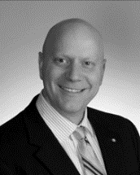
- Job Responsibility
- Budgets
- Financials Reports
- Your Rotary Club
- Your Rotary District
- Rotary International
- Risk Management

