Rotary Voices. Stories of Service.
2021 Annual (Virtual) District Conference
Thursday, April 15 – 6:30 pm Opening Evening
Saturday, April 17 – 8:30 - Noon
Sunday, April 18 – 9 am - noon
Thursday, April 15 – Session 1
6:30pm Welcome – Jon Catlin, District Governor
Housekeeping – Doreen Lanc
National Anthem – American Flag
Oh Canada – Canadian Flag
Invocation – Tom Schmidt
Opening comments from Holger Knaack, Rotary International President
7-30pm Courageous in the face of Change - Anne Bonney, Speaker/Author
7:45pm Cocktails and Conversation
_______________________________________________________________________________________________________
Saturday, April 17 – Session 2
8:30 am Opening Day 2
8:35 – 9am Diversity, Equity, and Inclusion - Jon Hankins, Rotary Club of Grand Rapids
9:10 – 9:30am Mark Fisher, President and CEO, Council of the Great Lakes Region
9:30 – 9:50am Nilam Bedi, Chair, Environmental Action Committee Rotary District 7070
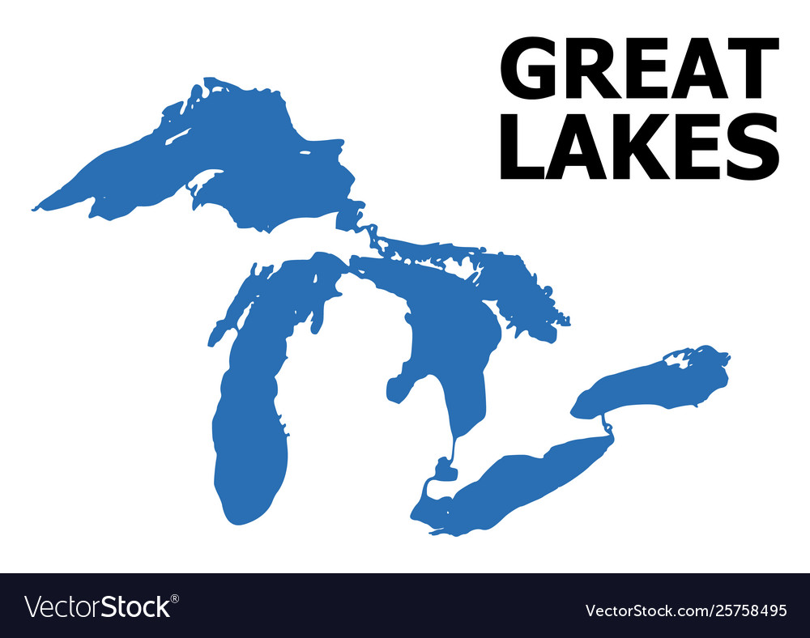
10 – 10:10am Great Lakes Watershed Cleanup – Jon Catlin, District Governor
10:30 –11am Chris Wells, Market Harborough, England
11:10 –11:40am Mark Andresky, District Education Facilitator – A Lesson in Leadership
_________________________________________________________________________________________________________
Sunday, April 18 - Session 3
9am Opening Day 3
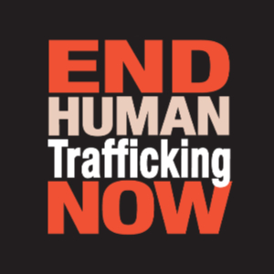
9:05am Honoring Rotarians, Tom Schmidt
10-10:30am Rotary’s involvement in Human Trafficking
Dave McCleary, Director, Rotarian Action Group against Slavery in America
10:45-11:15am Empowering Youth 5 minutes Lowell Early Act (taped presentation)
5 minutes Grand Rapids Interact
Amy Gibbs 5 minutes Muskegon Rotaract
5 minutes Global Scholar Nathan Reynolds 10 minutes Questions
11:30- 11:50 am Getting through my Rotary year in a Pandemic, District Governor, Jon Catlin
11:55-noon Elk Rapids Gary Chenoweth | Invitation to the 2022 District Conference
Noon Closing Remarks

