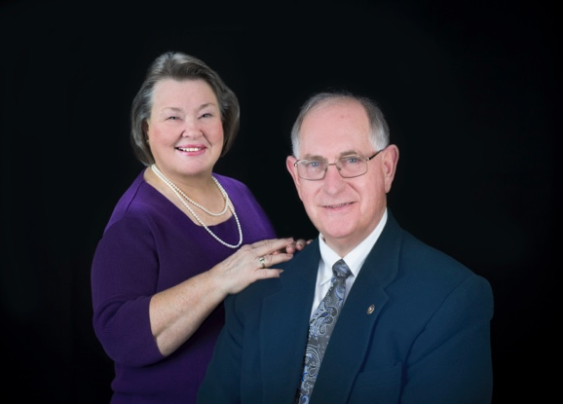 David F. Thomas
D6290 Governor 2019-20

Brief Biography
FAMILY:

Born in Glen Rogers, West Virginia in 1948; Dave’s family moved to Glen Burnie, Maryland in 1952 where he grew up, met, and married his High School Sweet heart in 1968. In 1971 they were blessed with the birth of a son, Michael; and in 1975 a daughter Jennifer. Jennifer works for Amazon in Seattle. Michael works for Bay Mills Resort & Casino in Brimley. Mike’s wife, Daniela, and three children Emily, Colin and Olivia are spoiled on a regular basis by the rest of the family

Employment:

- USMC attaining rank of, Sargent
- Johns Hopkins Hospital, Administrator
- University of Vermont, Director
- University of Missouri, Executive Director
- National Consultant HUP, Case Western, Fresno, Athens Georgia
- Burns Clinic, Executive Director
- Midwest Physicians, CEO
- Orland Park Surgical Center, President
- Michigan Heart, CEO

Recognition and Honors:

Dave is a member of the Petoskey Methodist Church. He is the current Commandant of Detachment 690 Marine Corps League and a 3rd Degree Master Mason. He has served as Club President, TOM AG, National President of the Academic Practice Assembly, and President of Illinois MGMA. He has also served on the Boards of the PHSCF, Michigan Chamber of Commerce, Traverse Symphony Orchestra, United Way, Salvation Army, and St. James Hospital. Dave was recently recognized as Alumni of the year by his Alma Mater Glen Burnie High School.

Education: BA Carson Newman, M.A.S. Johns Hopkins University, C.M.P.E. MGMA

