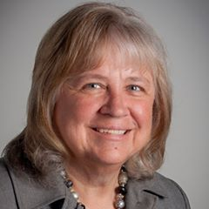

Cheryl has been a member of Rotary Club of Owosso since 2004 and has been involved in many club service projects and fund raisers. Cheryl served as club president in 2011-2012. During that time, the club’s activity increased in humanitarian projects with the club serving as the lead club in the first Hand Washing and Hygiene pilot project in the Dominican Republic. She served as the District Foundation Committee Global Grant Chairperson and was privileged to visit the Dominican Republic twice during that time. A past district governor from 2016-17, she is a member of the Paul Harris Society and served Zone 29 for 2 years as Assistant Rotary Coordinator with a focus on membership. Cheryl currently serves District 6310 as District Foundation Chair.

Cheryl has been involved in her local community through service on non-profit boards and committees, served as a presenter at Leadership Shiawassee on leadership issues, named Humanitarian of the Year by Memorial Healthcare, and received the Athena Award for leadership among women

