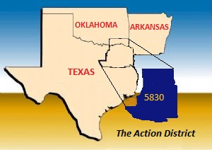
2018 District 5830 Foundation Banquet
February 10, 2018
Texas Freshwater Fisheries Center
5550 FM 2495
Athens, TX, 75752
Event Chair
PDG and District 5830 Foundation Chair Carroll Greenwaldt
Club Liaison
Anthony Chiles, President of Athens Rotary Club
3:30 p.m. Tour of Texas State Fishery
5:00 p.m. Social Time with cash bar
5:45 p.m. Pre-Dinner Welcome by DG Ted Huffhines and District Foundation Program
6:00 p.m. Dinner
6:45 p.m. Presentation by Brad Howard, Keynote Speaker
7:15 p.m. Awards and Event Wrap Up
8:00 p.m. Adjourn

Keynote Speaker:
Brad Howard | Rotary International Director 2015-2017, Rotary District 5170
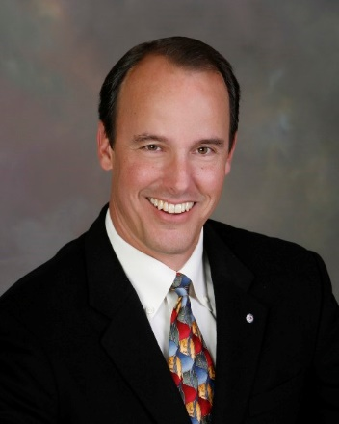
Brad Howard is a charter member of the Rotary Club of Oakland, California Sunrise. He has served Rotary in many leadership roles including a term as District Governor in 2002-2003, a three term on Rotary International’s Membership Development and Retention Committee as the North America Membership coordinator, and a 10 year term as the Zone Polio Coordinator. Brad is regarded as one of Rotary’s top trainers. For more than a decade he has trained Rotary leadership at PETS, GETS, GNATS and during two terms as an International Assembly Training Leader. As one of two global training leaders, he served an unprecedented three terms as International Assembly Seminar Trainer.
DG Ted Huffhines, said, “Brad is a wonderful Rotarian who you won’t want to miss! I look forward to having a great crowd as we celebrate our support of the Rotary Foundation and the wonderful work our district and clubs are doing to Make a Difference both at home and around the world!”
Cost per person: $45.00
Dress: Business

Hotel Information: Please call for your Hotel Reservation at your earliest convenience.
We have been told Hotels book early on the weekends in Athens.

1. Best Western Plus Royal Mountain. Suites (866-599-6674) King Bed + Breakfast @ $73.79 base rate + taxes = $84.85 per night for 2 person occupancy.

2. Holiday Inn Express (855-799-6861) King Bed, (no breakfast) @ $98.00+ tax is $112.00 per night for 2 person occupancy.

3. Tara Vineyard & Winery (866-599-6674) Room rates below include taxes
Cabin with Queen bed + breakfast @ $154 per night for 2 person occupancy
King Size Bed Room + breakfast @ $252 per night for 2 person occupancy
Larger Queen Room + breakfast @ $303.56 per night for 2 person occupancy

